CODEAUTOMATION.AI LLC · CHICAGO, ILLINOIS
GeoInfraLens AI
Technical Document and User Manual
AI-assisted road and sidewalk assessment on a map: upload survey photos, review what the AI suggests, and plan inspections.
Version | 1.0 (pilot development)
Date | October 28, 2026
Prepared by | Adnan Ghaffar, CodeAutomation.ai LLC
Live website | https://geo-ai-liart.vercel.app
Status | Platform built and working. AI model running as a labelled TRIAL (accuracy not approved). P5–P7 owner sign-off and P9 system testing pending.
Confidential. For the GeoInfraLens AI project team and approved partners.

Document control
Version | Date | Author | Changes
1.0 | Oct 28, 2026 | Adnan Ghaffar | First complete edition: access details, user manual with screenshots, technology stack, architecture, operations.

Contents
- Quick access: website and sign-in addresses
- Sign-in credentials
- What GeoInfraLens AI does
- Roles and what each person can do
- User manual: every screen, step by step
- Complete workflow from start to finish
- Technology stack and why we chose it
- System architecture
- The AI model
- Data model
- API overview
- Security and privacy
- Configuration settings
- Deployment
- Operations and maintenance
- Testing and quality
- Known limitations and open items
- Troubleshooting
- Glossary

About the screenshots
Screenshots were taken from the app with its built-in DEMO data (organization "DEMO City", San Francisco sample projects). Map backgrounds appear plain grey in these pictures because they were captured on a computer without internet access; on the live site the street map is shown under every map.

1. Quick access
Use these addresses to open the application. Always use the main address below, not the long deployment addresses that Vercel shows in its dashboard.
What | Address | Who uses it
Website (frontend) | https://geo-ai-liart.vercel.app | Everyone
Sign-in page | https://geo-ai-liart.vercel.app/sign-in | Everyone with an account
Request access (new organizations) | https://geo-ai-liart.vercel.app/request-access | Organizations that do not have an account yet
Organization requests (approval page) | https://geo-ai-liart.vercel.app/platform/requests | Platform admins only
Local website (developer computer) | http://localhost:5173 | Developer
Local API documentation | http://localhost:8000/api/docs | Developer (development mode only)

Important: when the live site works
The screens are hosted on Vercel, but the backend, database, photo storage and AI model currently run on the developer laptop and reach the internet through a Cloudflare tunnel. The live site therefore works only while that laptop is on, Docker is running and the tunnel window is open. See section 14 for how to move to an always-on server.

2. Sign-in credentials

2.1 Main administrator account
Sign-in address | https://geo-ai-liart.vercel.app/sign-in
Email | adnan@codeautomation.dev
Password | Chosen by the account owner when the account was created. It is deliberately not written in this document (see note).
Organization | Code Automation
Roles | Organization admin (Code Automation) and Platform admin (can approve new organizations)

Why the password is not in this document
Passwords are stored only as a one-way scrambled value (Argon2 hash), so nobody, including the developers, can read them back. Writing a password into a shared document would let anyone with the file sign in. Keep it in a password manager and share it only in person if needed.
Lost password: an organization admin can make a one-time reset link on the Team page. For the main admin, the operator can create a new admin with the command in section 15.

2.2 Demo accounts (only if the demo data is loaded)
The command python -m app.demo_data creates a separate "DEMO City" organization with one account per role. The password for all five is typed by the person who runs the command and is not stored anywhere else.
Email | Role in the demo
admin@demo-city.test | Organization admin
manager@demo-city.test | Project manager
reviewer@demo-city.test | Technical reviewer
collector@demo-city.test | Field collector
viewer@demo-city.test | Viewer

3. What GeoInfraLens AI does
GeoInfraLens AI helps a city or road department find road damage from survey photos and decide where to inspect first. Field staff upload photos taken on the road; an AI model suggests possible problems (potholes, surface cracking, pavement deterioration); a qualified reviewer checks every suggestion; managers then see a priority list, plan inspections and export reports.

3.1 Rules built into the system
- AI results are only suggestions. Nothing the AI finds counts until a technical reviewer verifies it.
- AI certainty is never severity. Severity is chosen by the reviewer on the organization's scale.
- The AI's original answer is kept forever. Reviewer corrections are stored separately; the database refuses changes to the original prediction.
- Photo GPS is approximate. Locations from photos are labelled "approximate" until a reviewer confirms or corrects them; missing locations are flagged, never invented.
- Sidewalk observations are manual. The AI looks only at roads; sidewalk problems are recorded by people.
- Every protected request is permission-checked. People see only their own organization and the projects they belong to.
- Everything important is recorded. Reviews, role changes, settings and exports go to an activity history that cannot be edited.

4. Roles and what each person can do
There are three levels of roles. Organization roles apply across the whole organization; project roles apply inside one project. One person can hold several project roles (for example project manager and technical reviewer).
Role | Level | Main abilities
Platform admin | Whole platform | Reviews requests from new organizations; approves (creates the organization) or rejects. Given only by a server command.
Organization admin | Organization | Invites people, changes roles, makes password reset links, edits finding types and settings, sees all history, manages every project.
Organization manager | Organization | Can create projects (and becomes their project manager).
Organization member | Organization | No project access until added to a project.
Project manager | Project | Edits the project, manages its team, uploads photos, starts the AI check, plans inspections, creates and shares reports.
Technical reviewer | Project | The only role that verifies, rejects or marks findings for a field check, and sets severity.
Field collector | Project | Uploads photos, fixes missing locations on own photos, starts the AI check on own photos, records inspections assigned to them.
Viewer | Project | Sees verified findings, the priority list and shared reports only.

5. User manual
This section walks through every screen in the order people normally use them. Each part explains what the screen is for, what you can do on it, and what to expect.

5.1 Sign in
Open https://geo-ai-liart.vercel.app/sign-in. Enter your email and password and press Sign in. The eye button shows or hides the password. After five wrong tries for one email the app waits 15 minutes before allowing more attempts.
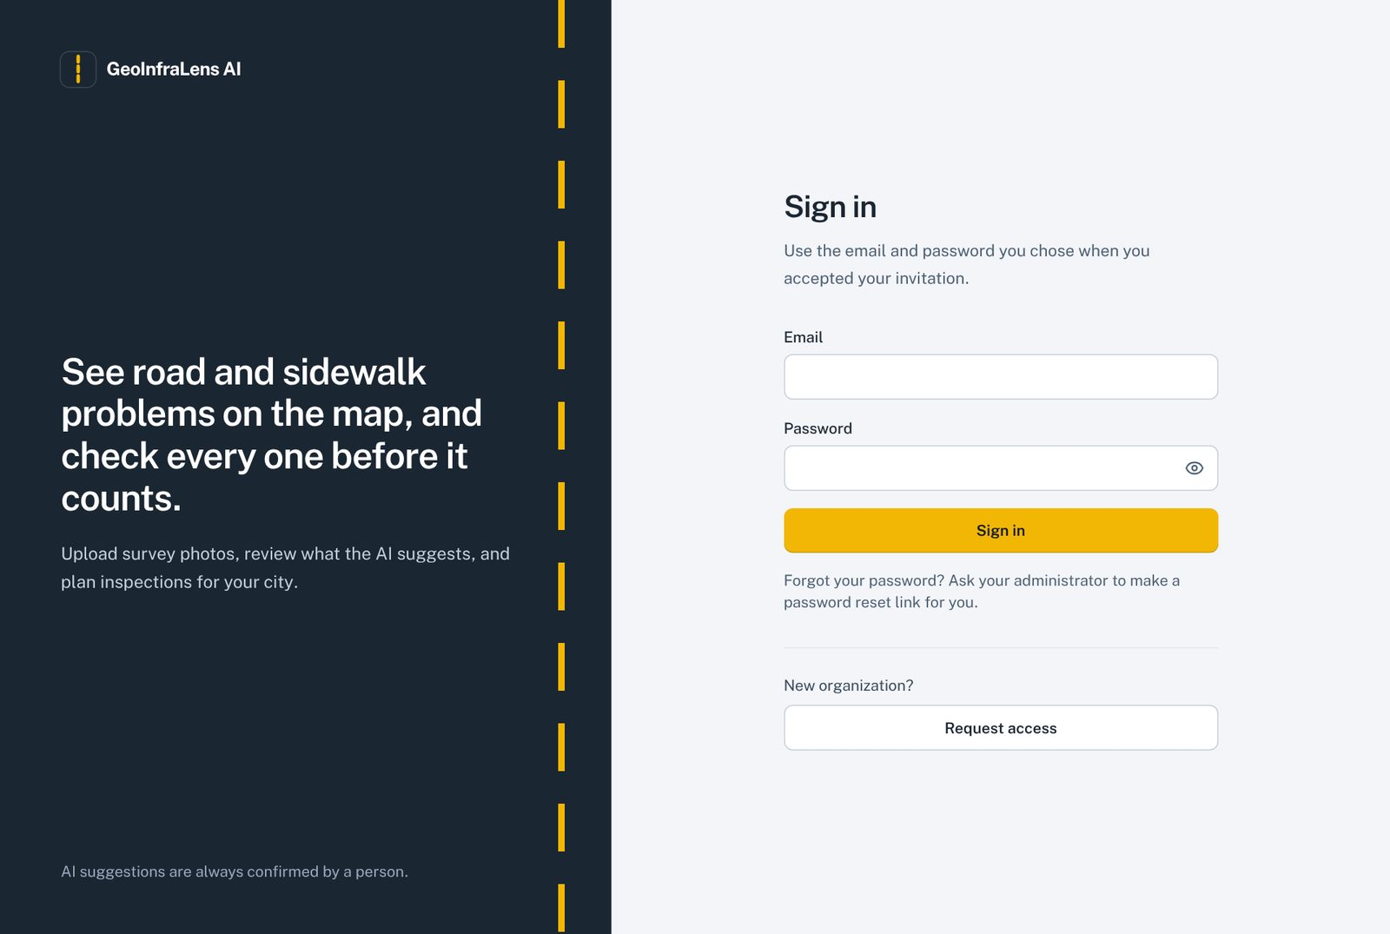
Figure 1. Sign-in page with the "Request access" button for new organizations.
- Forgot your password? Ask your organization administrator to make a password reset link for you.
- New organization? Click Request access (section 5.2).

5.2 Request access for a new organization
A city or agency that does not have an account fills in a short form. No password is asked here; nothing is created until a platform admin approves.
- On the sign-in page click Request access.
- Fill in organization name, city or agency, your name and work email. Phone and a short note are optional.
- Click Send request. A confirmation appears; you cannot sign in yet.
- When approved, you receive an invitation link by email (sent by the platform admin) to set your password.
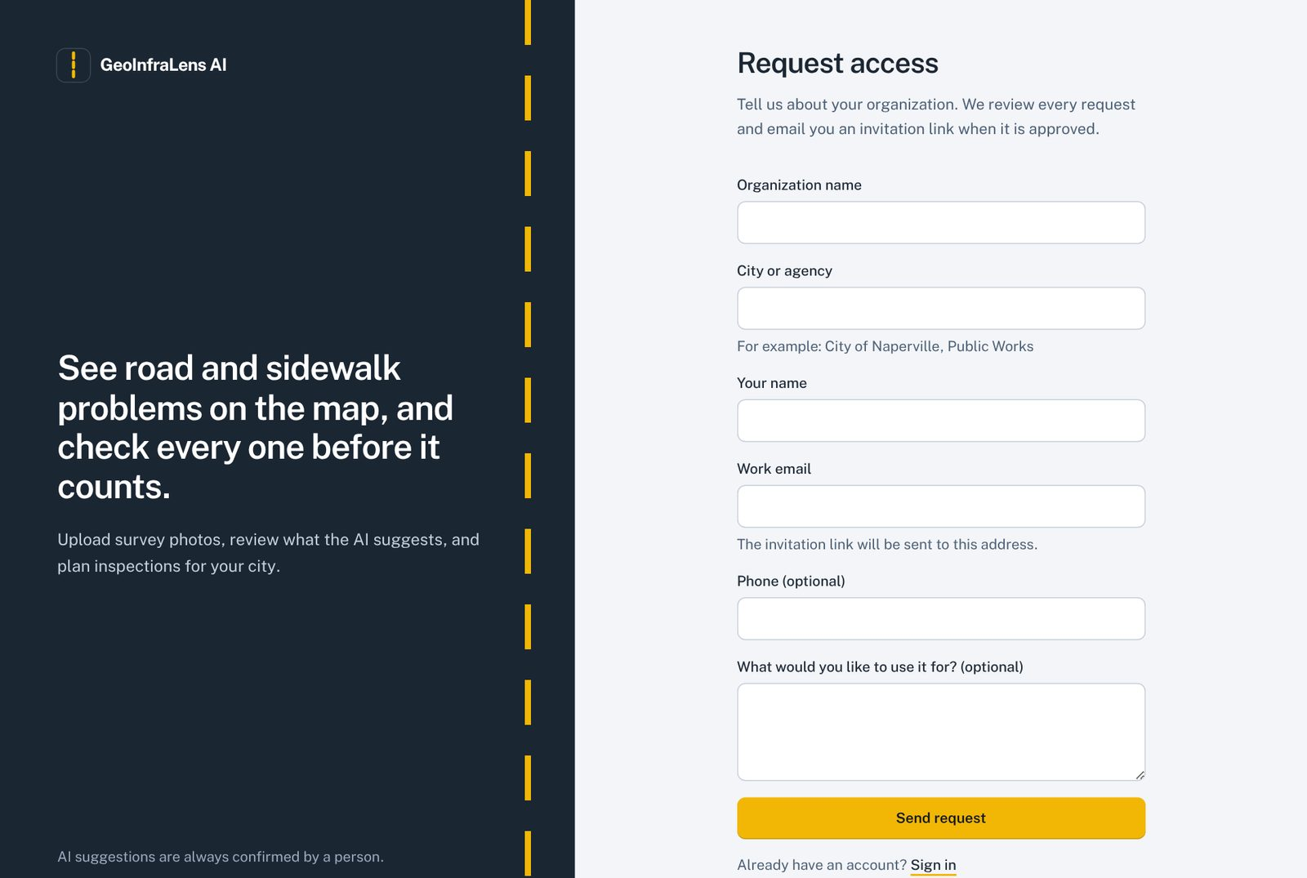
Figure 2. Request access form. Missing fields are explained in red under each box.
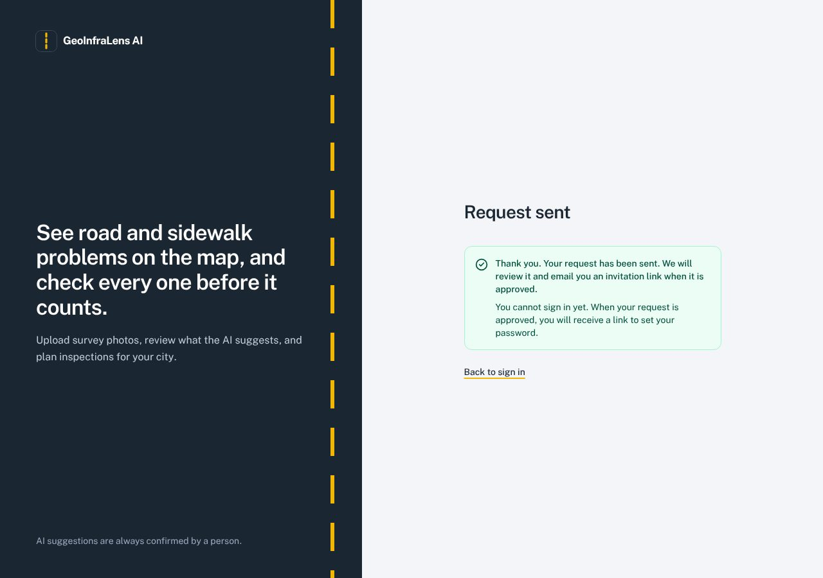
Figure 3. Confirmation after sending a request.
- One waiting request per email address.
- At most 5 requests per hour from one network, and a hidden field that only robots fill in, protect against spam.

5.3 Approve or reject organizations (platform admin)
Platform admins see a Platform → Organization requests item in the left menu, with a yellow number for requests that are waiting.
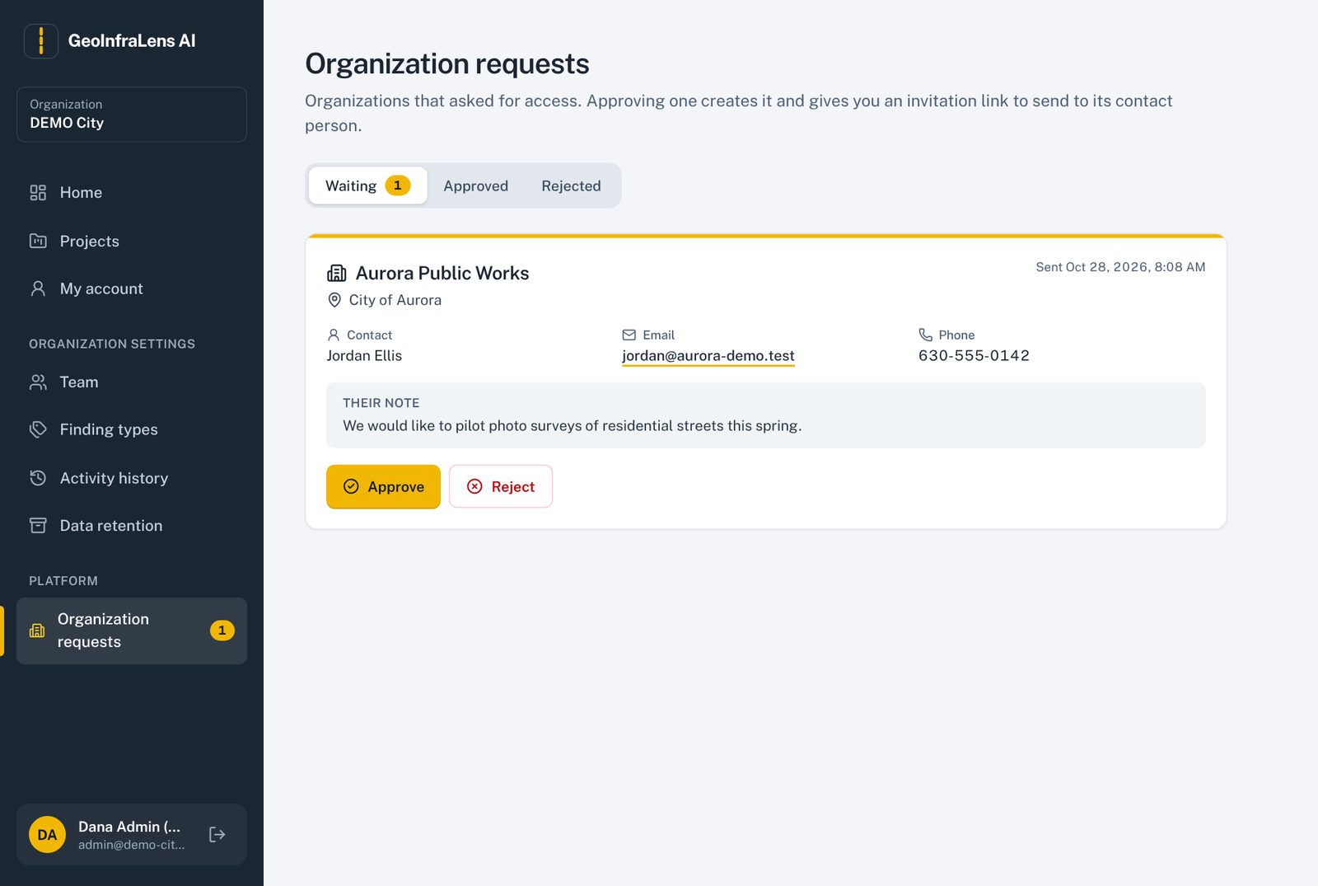
Figure 4. Organization requests: waiting requests with contact details and the organization's note.

To approve
- Click Approve on the request. Optionally add a note for the history.
- Click Approve and create organization. The organization is created with its starting settings.
- A green box shows a one-time invitation link. Click Copy and email it to the contact person. It works once and expires after 7 days; it is not shown again.
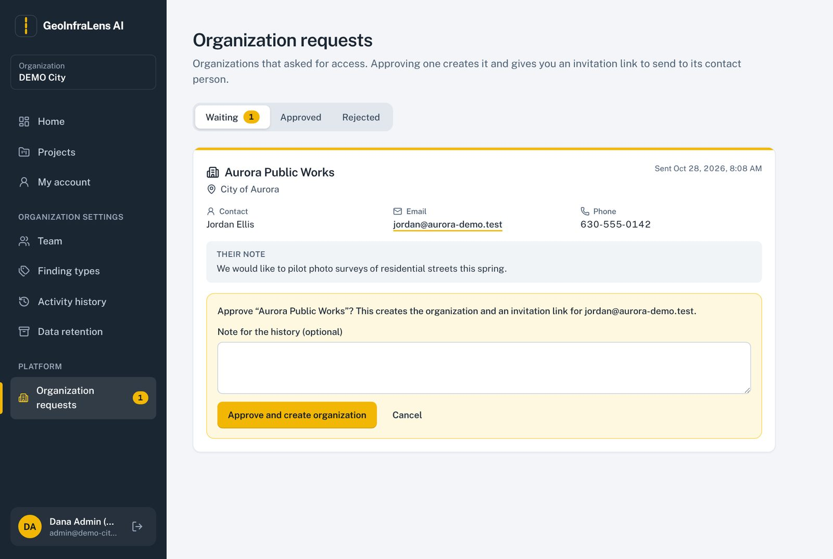
Figure 5. Approving: the confirmation box before the organization is created.
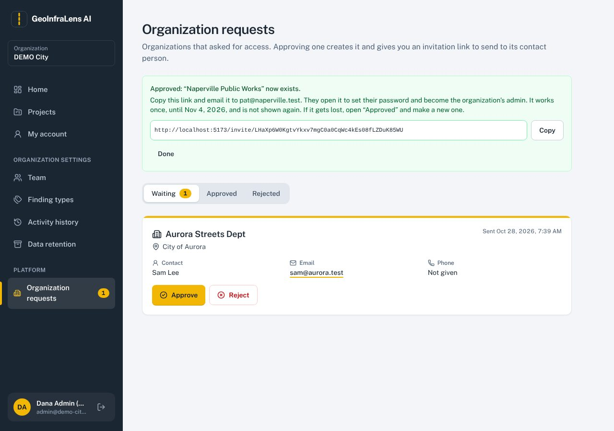
Figure 6. After approval: copy the invitation link and send it to the contact.

To reject
Click Reject, type a reason (kept in the history) and click Reject request. Nothing is created and the same email may ask again later.

Lost or expired link
Open the Approved tab and click Make a new invite link on that organization. The old link stops working.
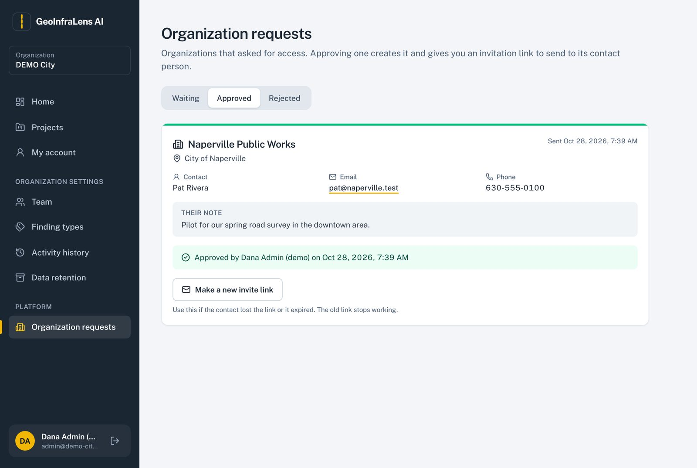
Figure 7. Approved tab: who approved, when, and the button for a new invitation link.

5.4 Accept an invitation (create your account)
Everyone joins through an invitation link: new organization admins (from the platform admin) and team members (from their organization admin). Opening the link shows the organization and role; enter your name and a password of at least 10 characters and click Create account. If your email already has an account, you only sign in and the new membership is added.
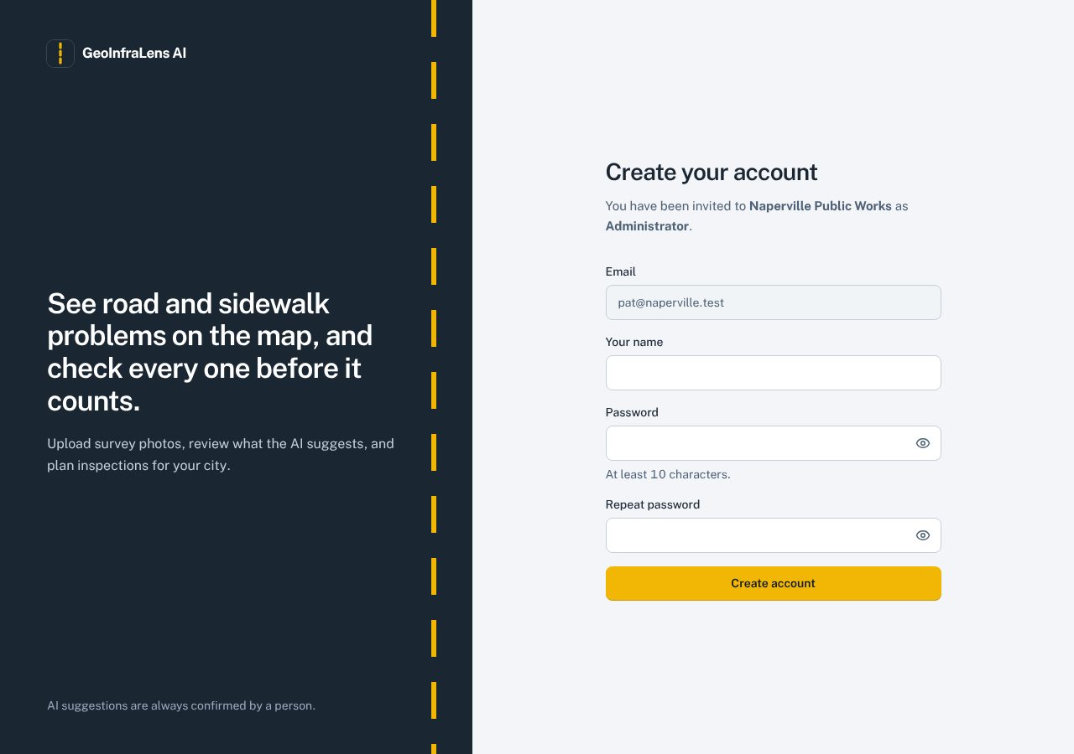
Figure 8. Invitation page: the email is fixed; the person chooses their own password.

5.5 Home and "What to do next"
Home starts with a short to-do list made for your role, with one button per job: for example AI suggestions waiting for a reviewer, photos without a location, new photos waiting for the AI check, or open inspections. Below it, Numbers and charts summarise the chosen period (7, 30 or 90 days, or all time) and project.
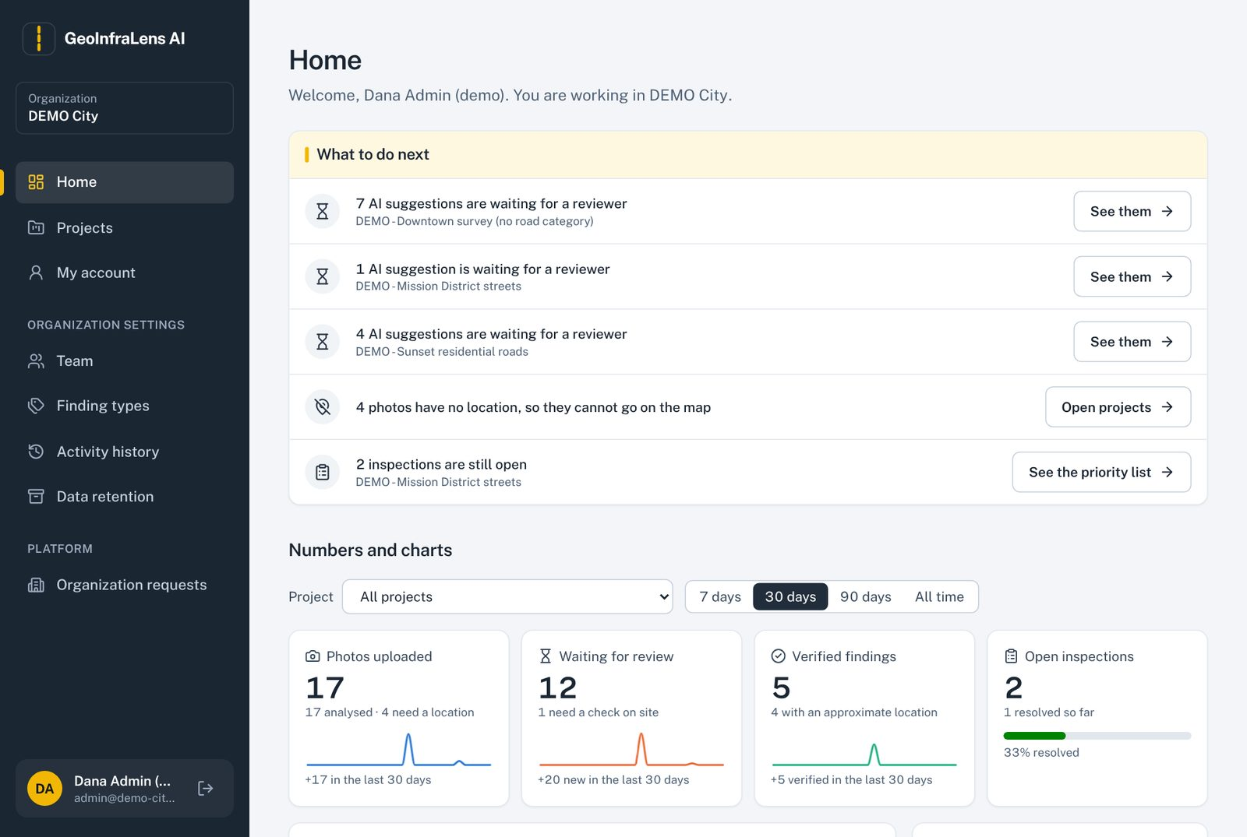
Figure 9. Home for an organization admin: to-do list first, then numbers and charts.
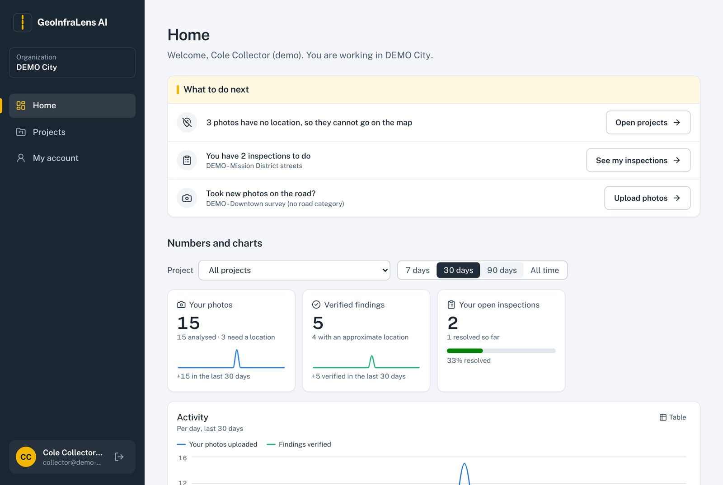
Figure 10. Home for a field collector: only what a collector can act on, including "Upload photos".
The app also works on phones: the menu moves to a button at the top and tables become cards.
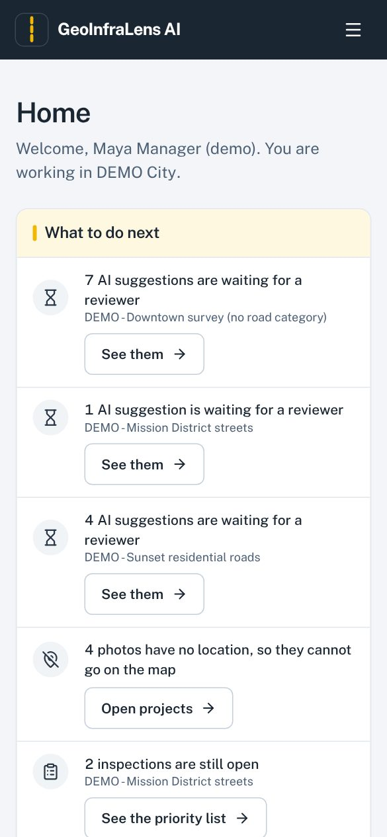
Figure 11. Home on a phone.

5.6 Projects
A project is one road survey: an area on the map, the kinds of problems to look for, and the people who work on it. The Projects page lists every project you can open with its photo, location and warning counts. Organization admins and managers see Create project. Tick Show archived projects to include archived ones.
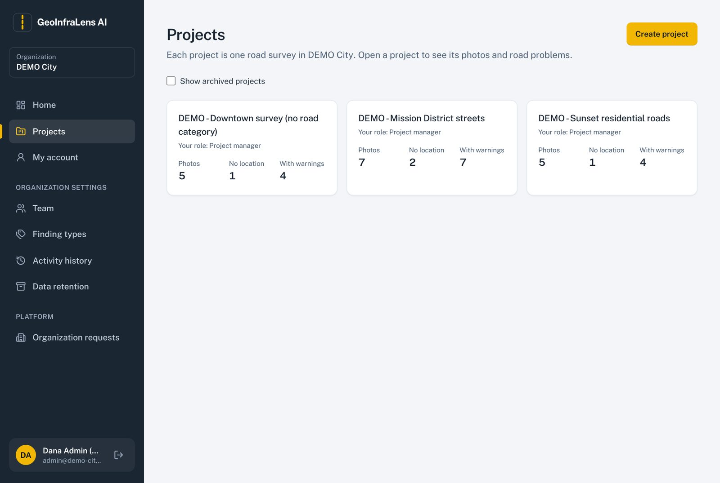
Figure 12. Projects list.

5.7 Create a project and set the survey area
- Click Create project.
- Enter the project name. Road category, partner reference and survey dates are optional.
- Tick the finding types this survey looks for (AI-suggested road types and manual sidewalk observations).
- Tick at least one technical reviewer. You become the project manager automatically.
- Set the survey area in one of three ways (below), then click Save project.
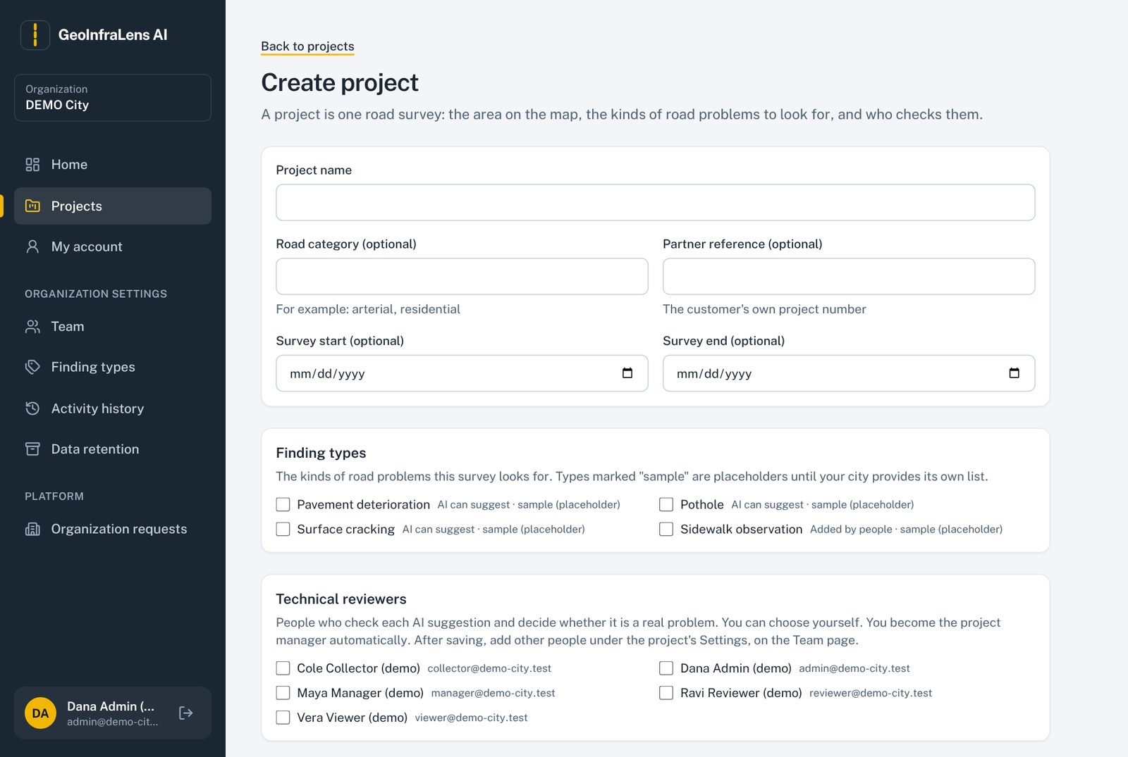
Figure 13. Create project: details, finding types and technical reviewers.

Three ways to set the survey area
- Search a place: type a street, neighborhood or city in "Find a street, neighborhood or city", press Search, then click a result. Cities and neighborhoods use their real outline; a street gets a rectangle around it; a single address gets a block-sized area. Search uses OpenStreetMap and sends only the typed words.
- Draw on the map: choose Draw a shape, click the map to add corners and click the first corner to finish. Several shapes are allowed.
- Upload a file: Upload area file accepts GeoJSON in longitude/latitude (WGS 84).
Use Move or adjust to drag the shape or its corners, and Clear all to start again.
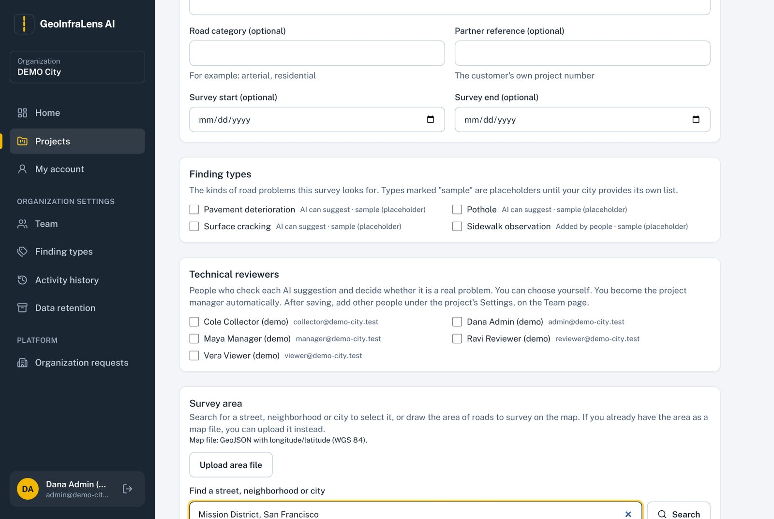
Figure 14. Address search: matching places, each marked as an outline or a rectangle.
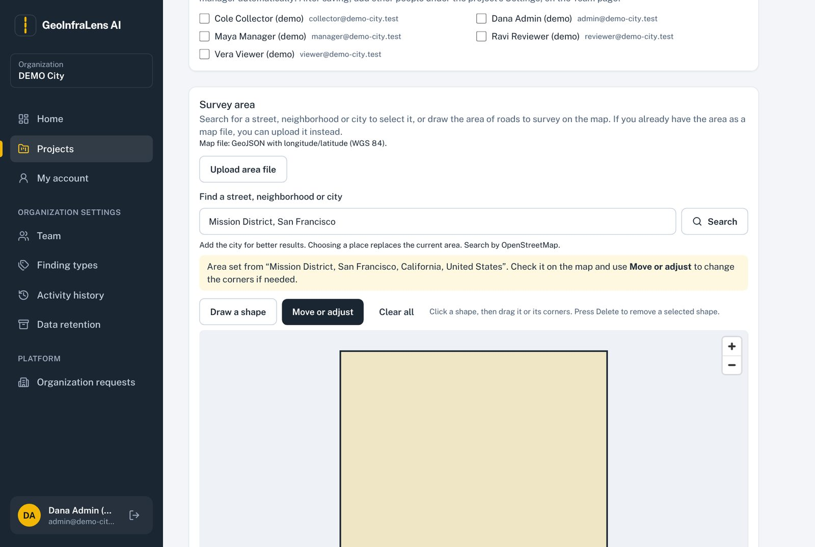
Figure 15. After choosing a place the area is selected on the map, ready to adjust.

5.8 Project overview
Each project has six tabs: Overview, Photos, Findings, Priority (My inspections for collectors), Reports and Settings. Overview shows warnings (for example blurry or dark photos), the project's own to-do list, its numbers and charts, and a large yellow card when new photos are waiting for the AI check.
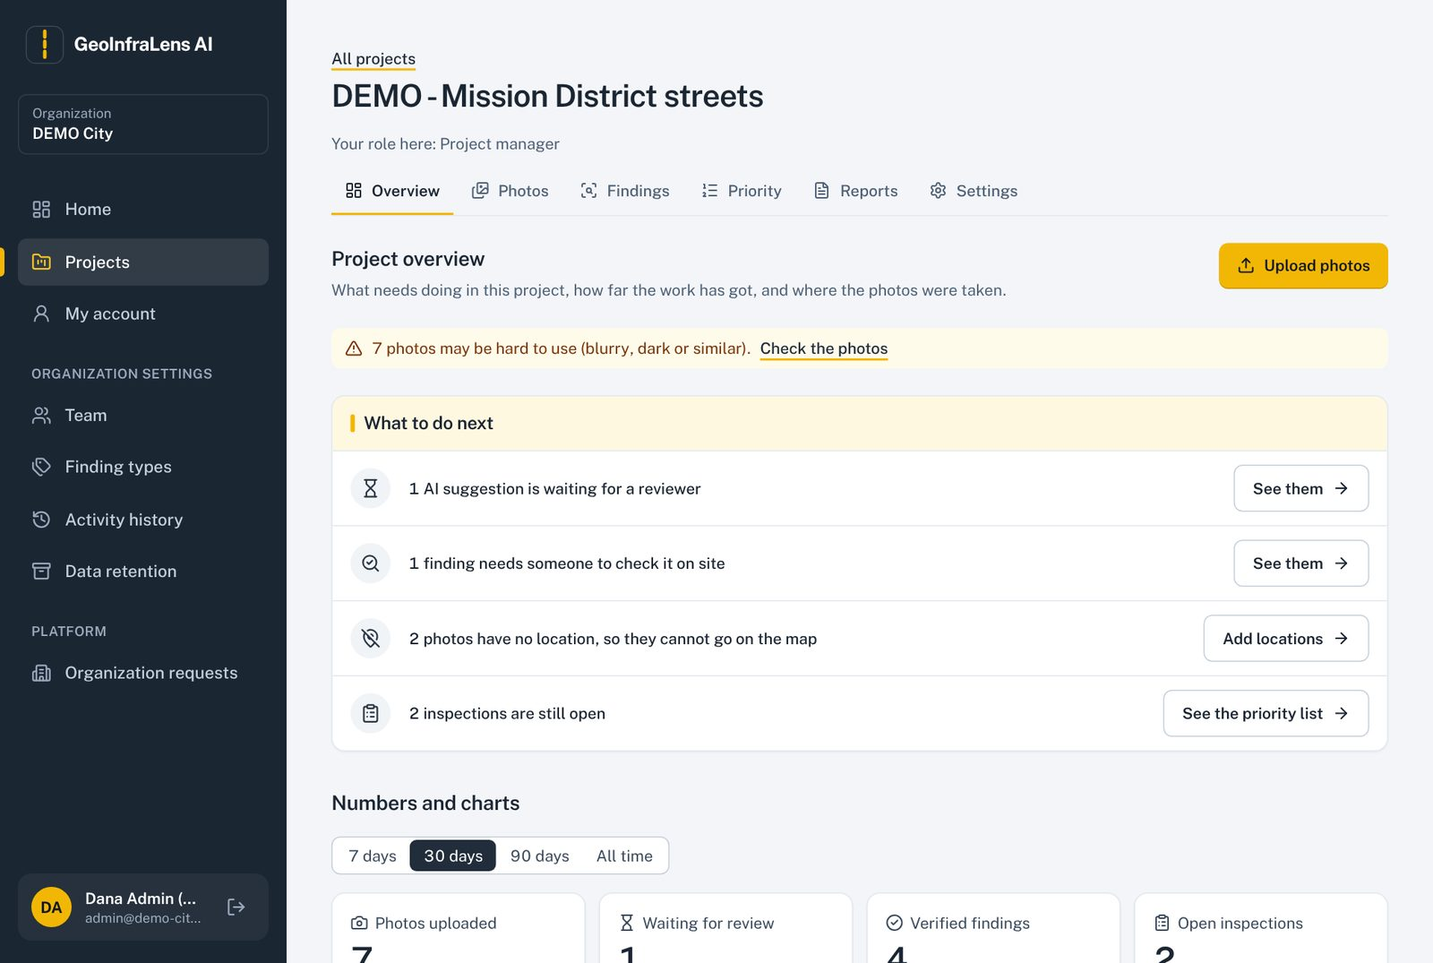
Figure 16. Project overview with warnings and the to-do list.

5.9 Upload photos
- Open the project and click Upload photos.
- Drag photos onto the box or click Choose photos (JPEG or PNG, up to 20 MB each).
- Tick "I am allowed to upload these photos…". If a photo has no GPS, you can tick "use this device's current location" only when you are standing where the photos were taken.
- Click Upload. Each photo shows its progress; failed ones can be retried. Duplicates of photos already in the project are detected and not saved twice.
- When finished, the yellow card offers Check N photos now to send them to the AI.
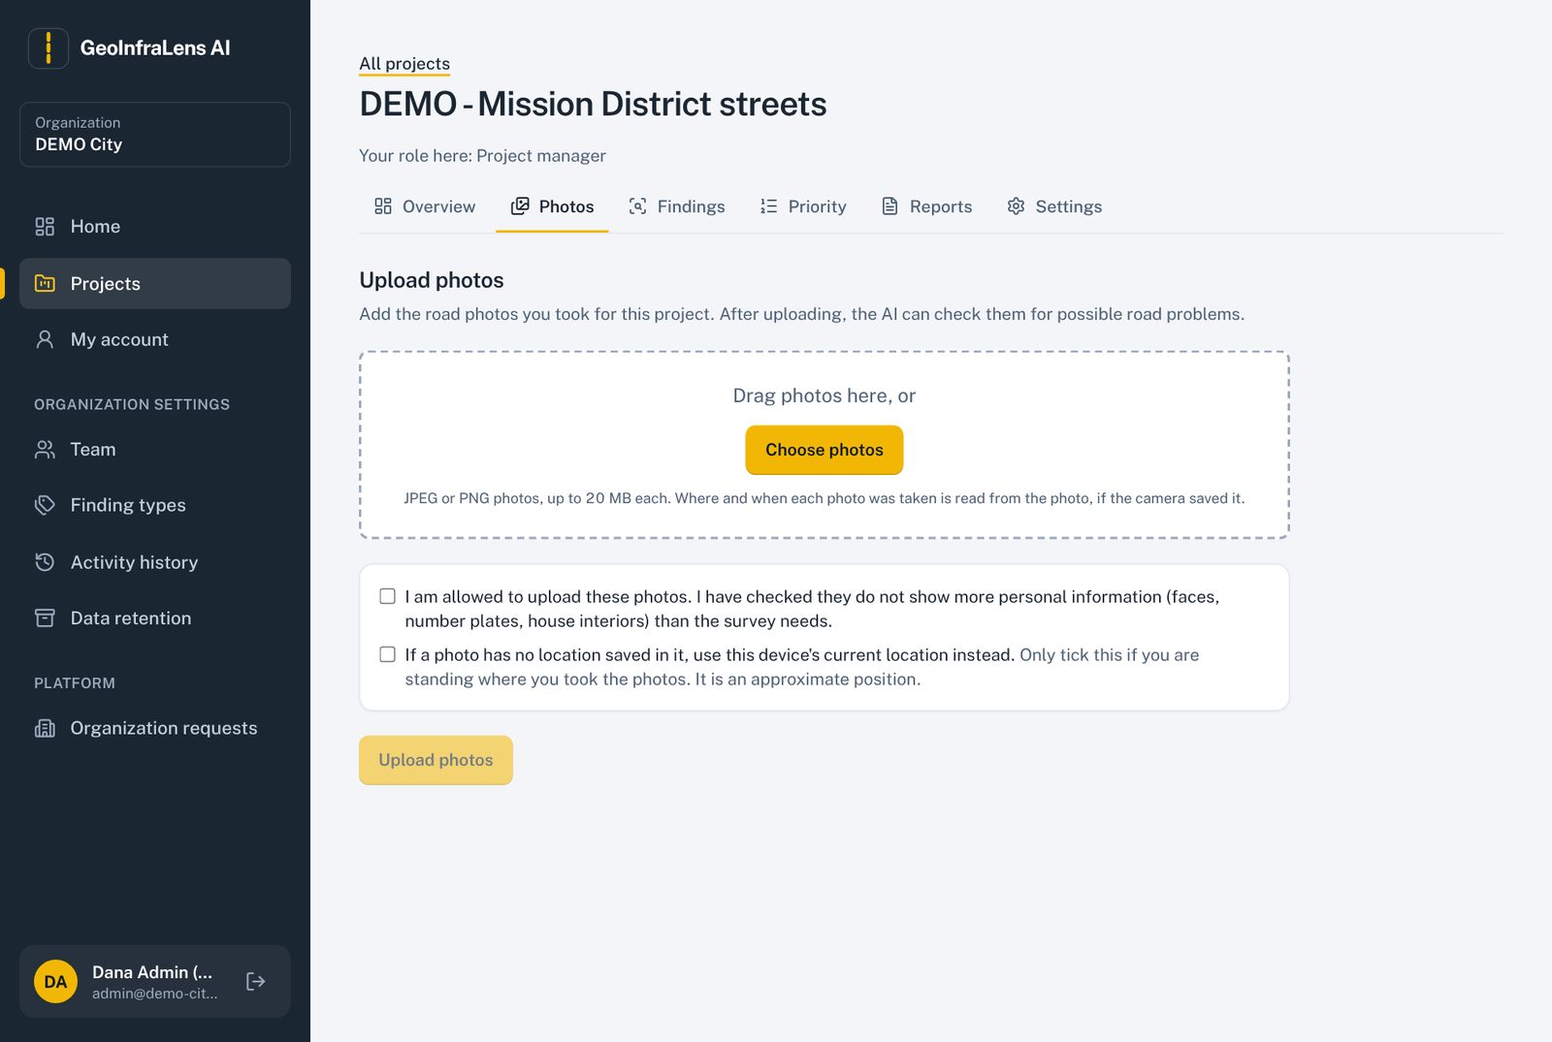
Figure 17. Upload page with the permission tick box.
The app reads the time and GPS position saved by the camera, checks whether the photo is inside the survey area, and flags photos that may be blurry or dark. Original photos are never changed.

5.10 Photos and the AI check
The Photos tab lists every photo with its location status, flags and AI status. New photos show a yellow card "N photos are waiting for the AI check" with a button that sends them all. Each photo then shows "Waiting", "Checking", "AI found N possible problems", "AI found no possible problems" or "AI check failed" with Try again.
- Add location on map: for photos without GPS, pick the spot on a map. The location is marked approximate.
- Only photos without a location: a filter to find them quickly.
- Results from the trial model are labelled "TRIAL MODEL: accuracy not approved".
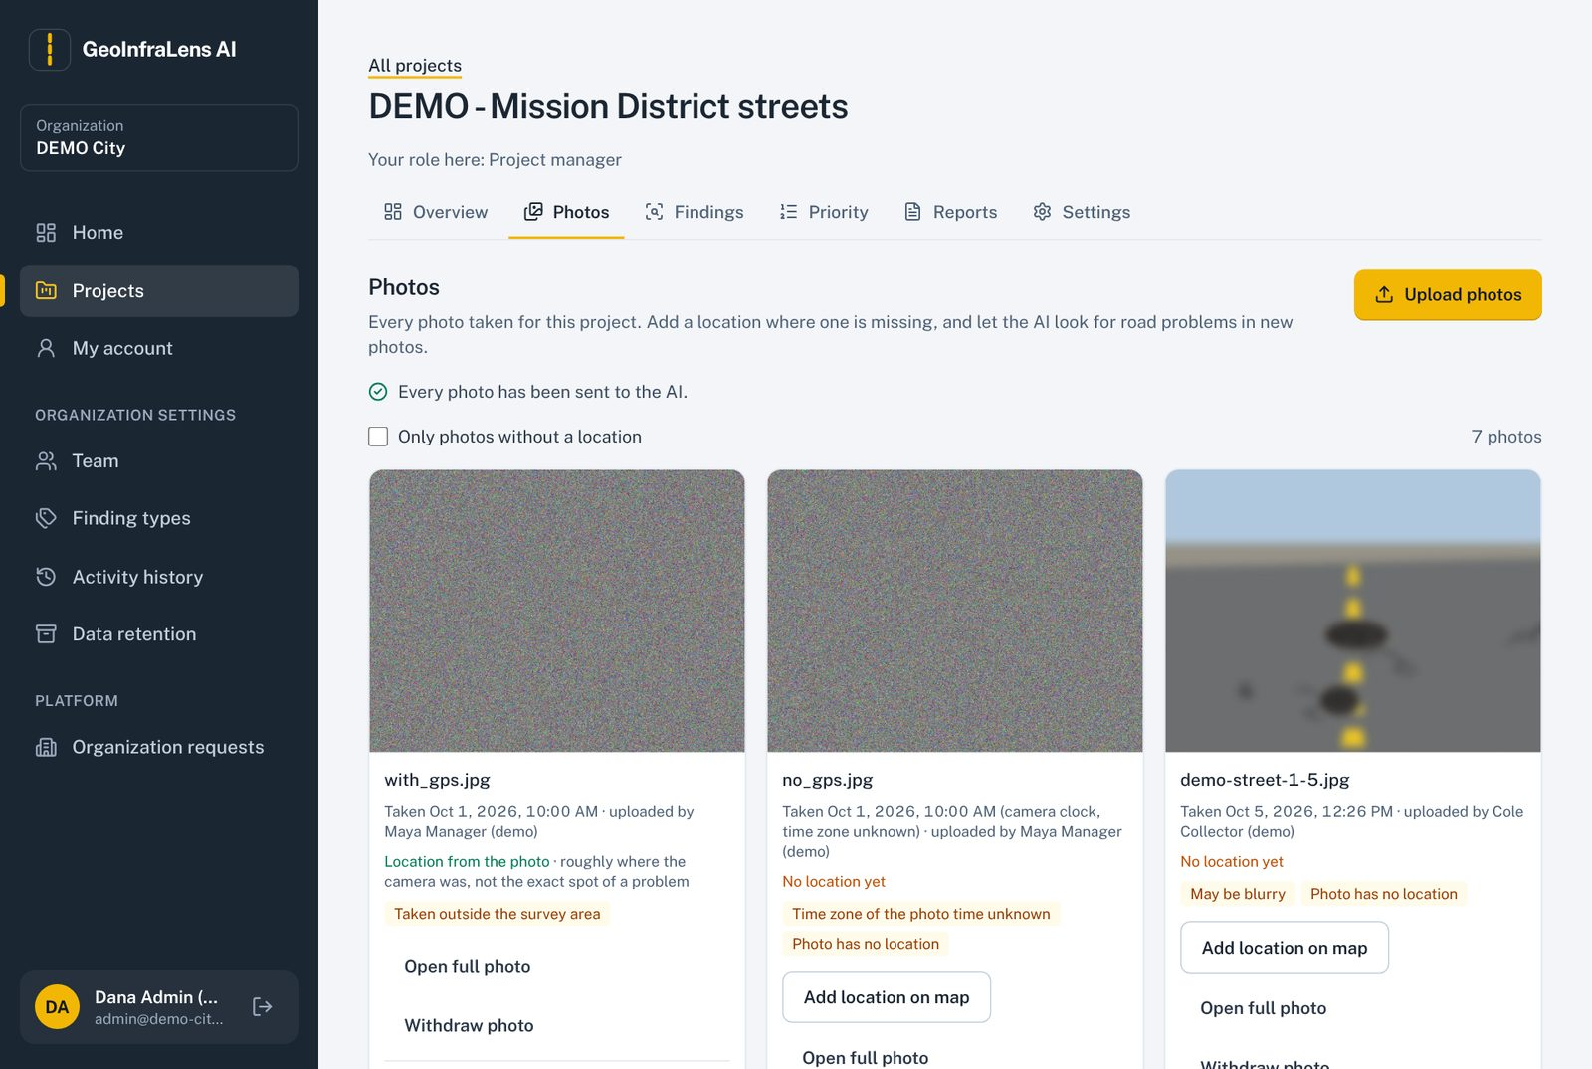
Figure 18. Photos tab with location status, quality flags and the AI check card.

5.11 Findings: map and list
Findings are possible problems suggested by the AI or added by people. The map and the list stay in step: clicking one highlights it in the other. Filters (status, type, severity, location, dates) are kept in the web address so a filtered view can be shared. Clicking a finding opens its details with its photo, history and location (with an "Open in Google Maps" link). Add observation records a manual finding, including sidewalk observations.
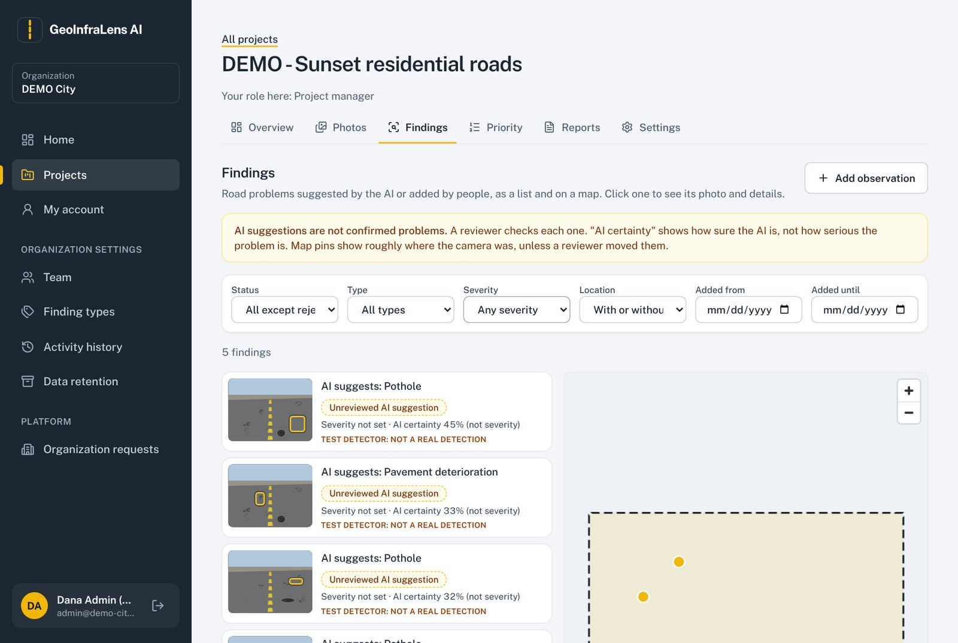
Figure 19. Findings: list on the left, map on the right, filters on top.

5.12 Review a finding (technical reviewer)
- From Findings or the Home to-do list, open a suggestion waiting for review.
- Look at the photo. Zoom in, and switch the AI box on or off with Hide AI box.
- Choose the problem type (or keep the AI's suggestion), the severity on your organization's scale, and add notes.
- If the pin is wrong, move it on the map; the corrected location is stored separately from the photo GPS.
- Decide: Verify, Reject (with a reason) or Needs field check. Keyboard shortcuts are shown on the screen.
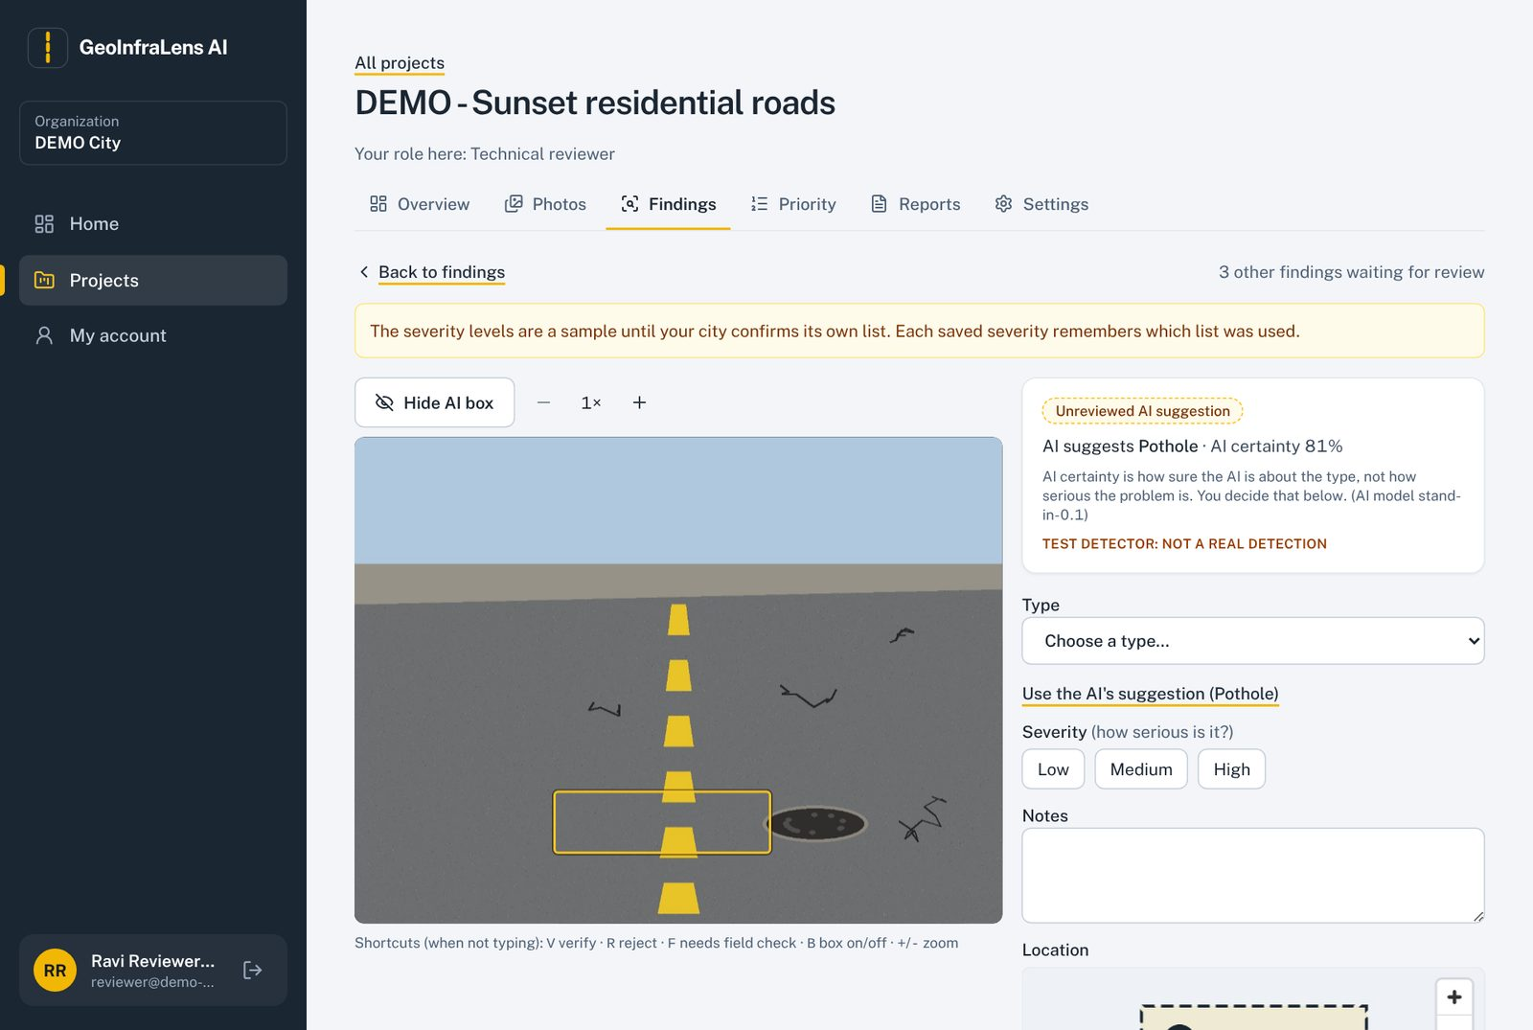
Figure 20. Review screen: photo with the AI box, type, severity, notes and location.
Rules on this screen
The AI certainty shown is how sure the AI is that something is there; it is not severity.
If two reviewers save the same finding at once, the second is told to reload; nothing is overwritten.
Leaving with unsaved changes asks for confirmation.

5.13 Priority and inspections
The Priority tab ranks verified findings by an inspection priority score. "How this score was calculated" shows every input (reviewed severity, road category, nearby facilities), its weight and its contribution, and lists missing inputs instead of guessing them. The weights are sample settings until the client confirms them; each change creates a new version.
- Plan inspection: choose who will inspect and when.
- Record the result: inspected, or resolved with a note or photo as evidence.
- Reopen a resolved finding if the problem comes back; the history is kept.
- Field collectors see this tab as "My inspections" with only the inspections assigned to them.
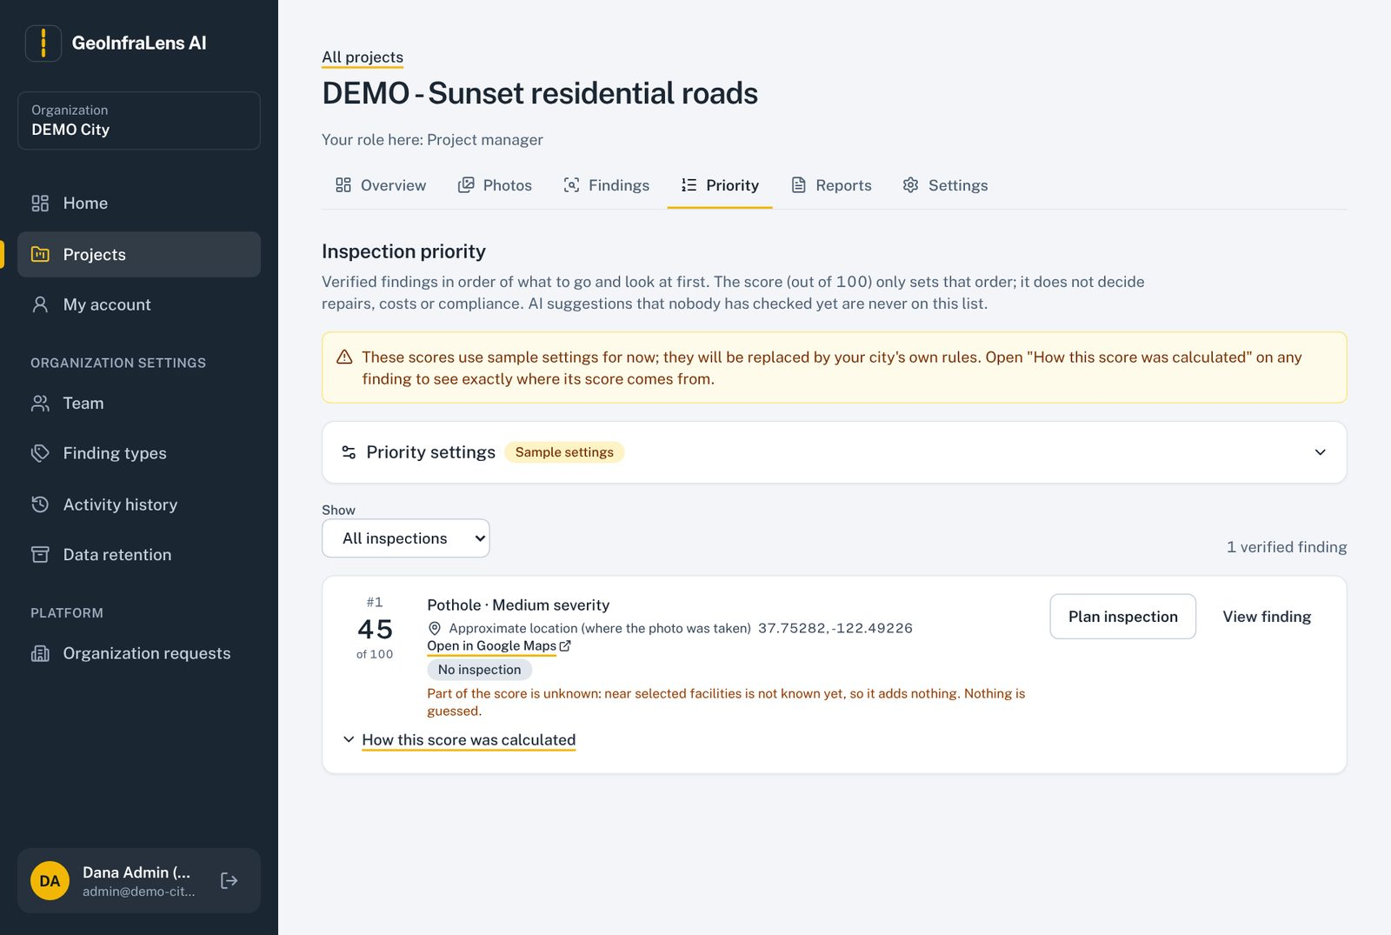
Figure 21. Priority list with the score, its explanation and inspection actions.

5.14 Reports
Managers make CSV (Excel), GeoJSON (map data) or PDF summary reports. Reports include only verified findings unless "Also include unreviewed AI suggestions" is ticked, in which case they are clearly labelled and cannot be shared with viewers. Each report states its filters, date and limitations, is built in the background, and every download is logged. Shared reports become visible to viewers and reviewers.
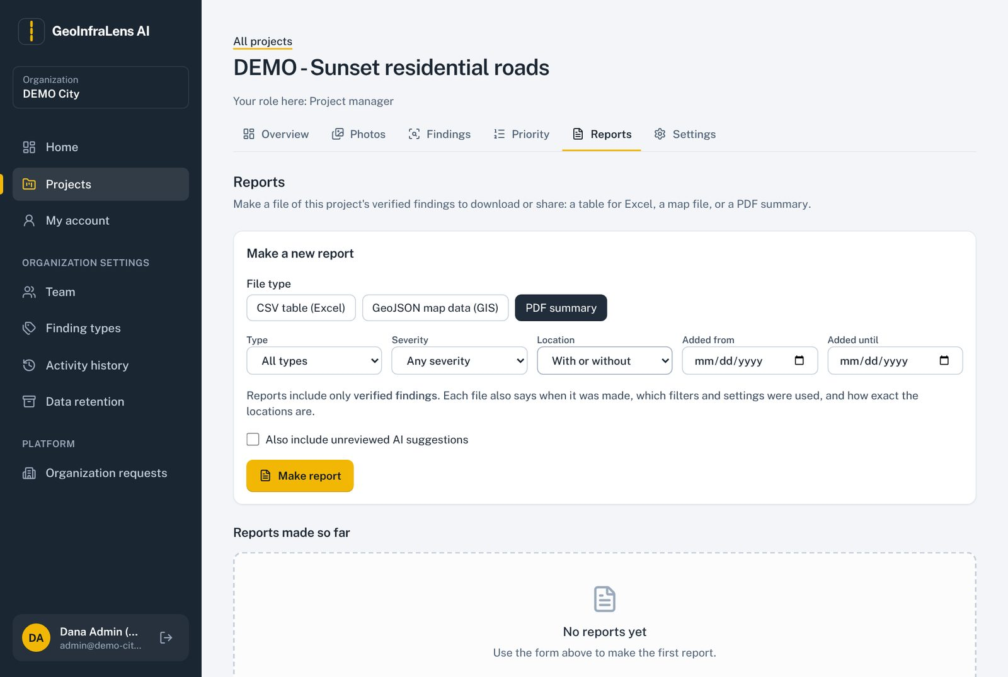
Figure 22. Reports: choose the file type and filters, then Make report.

5.15 Project settings: details, team and history
Settings has three parts. Project details edits the name, area, dates and finding types. Team adds people who are already in the organization and gives them project roles (a person can have more than one role). History shows everything that was done in this project, by whom and when; it cannot be changed.
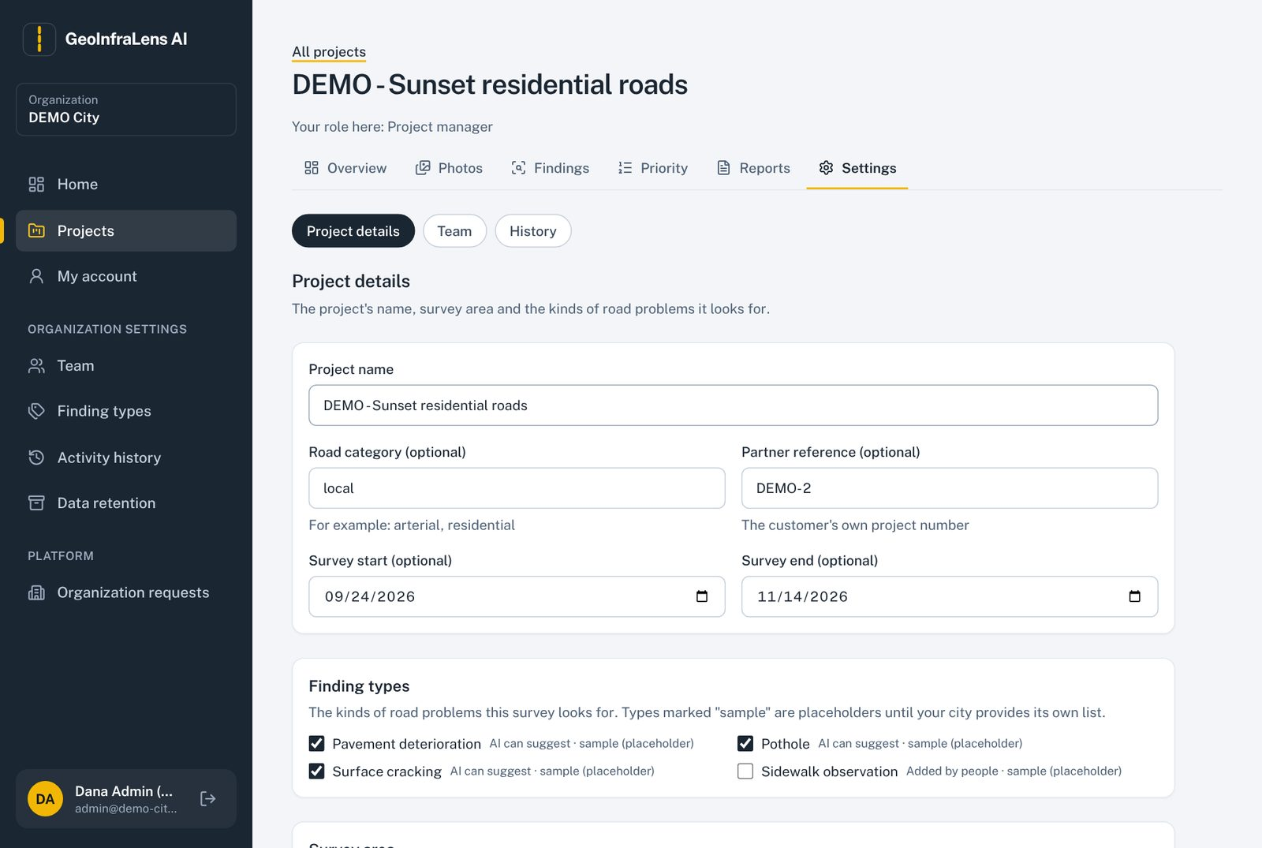
Figure 23. Project details.
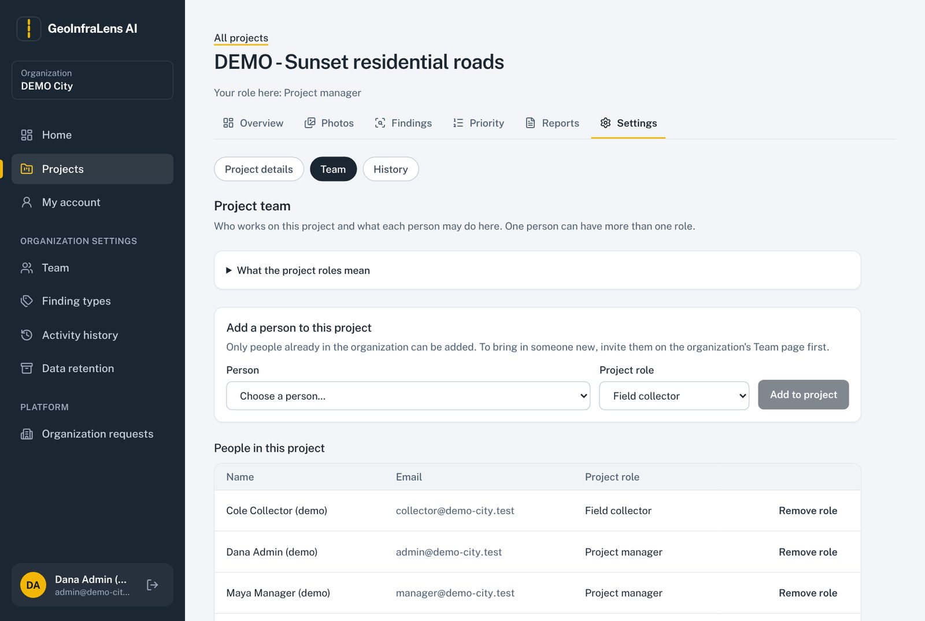
Figure 24. Project team: add a person and choose a role.
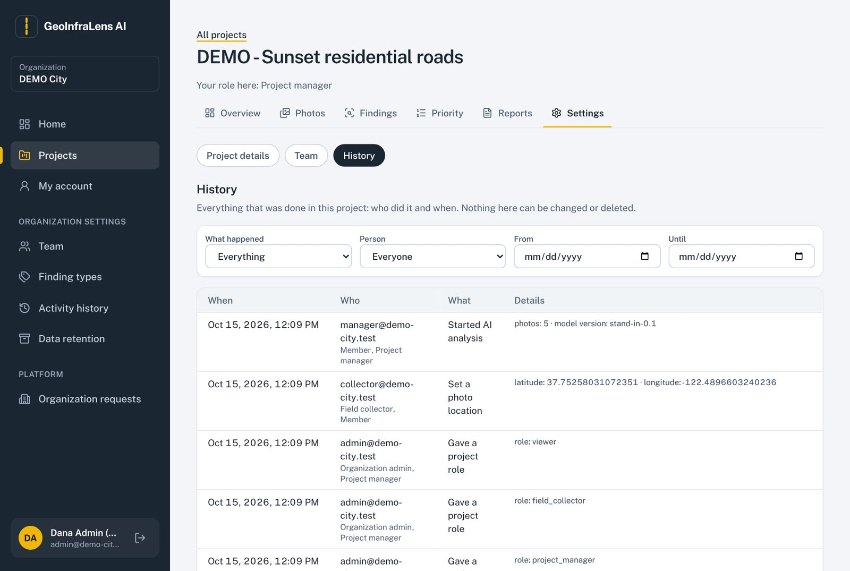
Figure 25. Project history.

5.16 Organization settings

Team
Organization admins invite people (email and organization role), change roles, remove members and make one-time password reset links. Invitation and reset links are shown on screen once, to copy and send; the app does not email them yet. The last administrator cannot be removed.
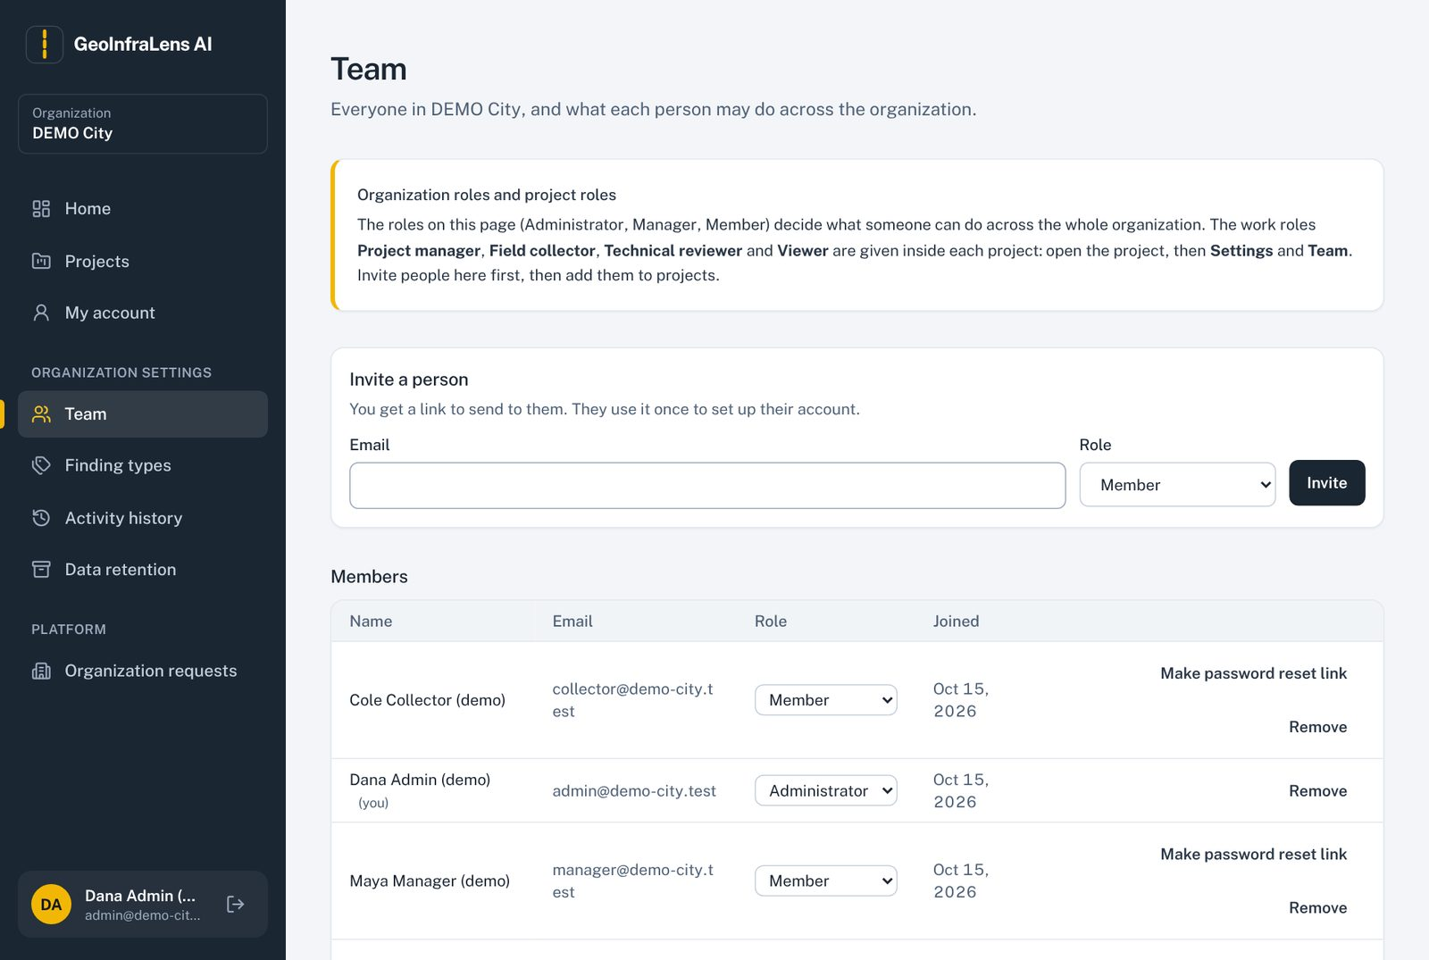
Figure 26. Organization team: invite people and manage members.

Finding types and severity scale
Lists the kinds of road problems the organization records and the severity levels reviewers choose from. Both are sample (placeholder) values until the client confirms its own list and engineering definitions.
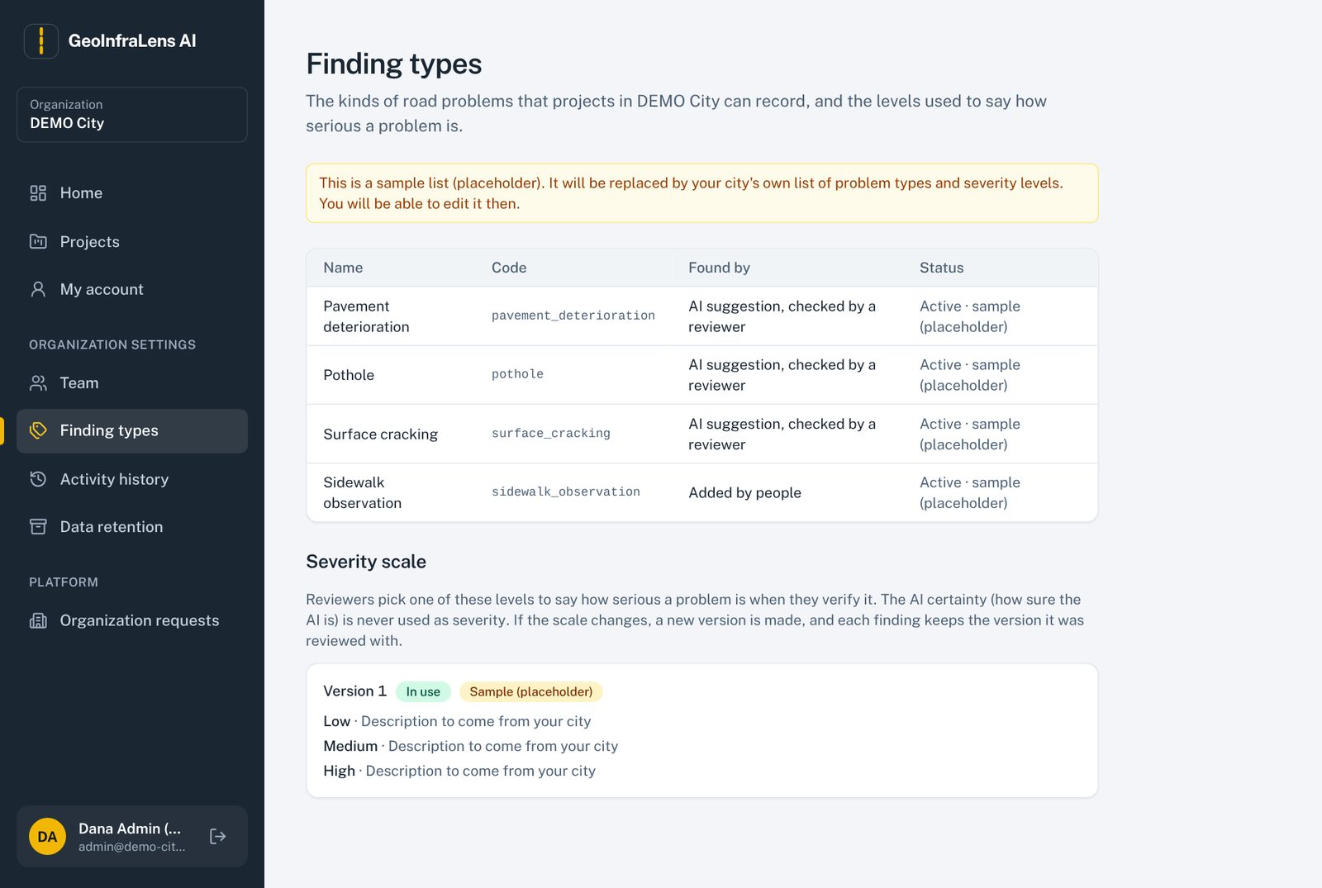
Figure 27. Finding types and the severity scale.

Activity history
A filterable record of who did what across the organization (sign-ins, invitations, reviews, settings, exports). Entries can never be changed or deleted.
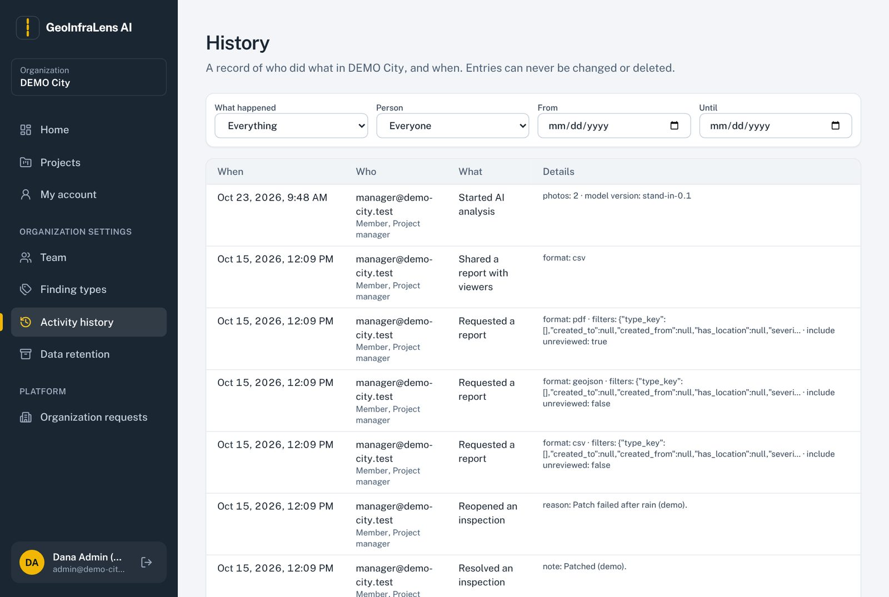
Figure 28. Organization activity history with filters.

Data retention
Explains that nothing is deleted automatically until the organization confirms how long photos, findings and reports must be kept.
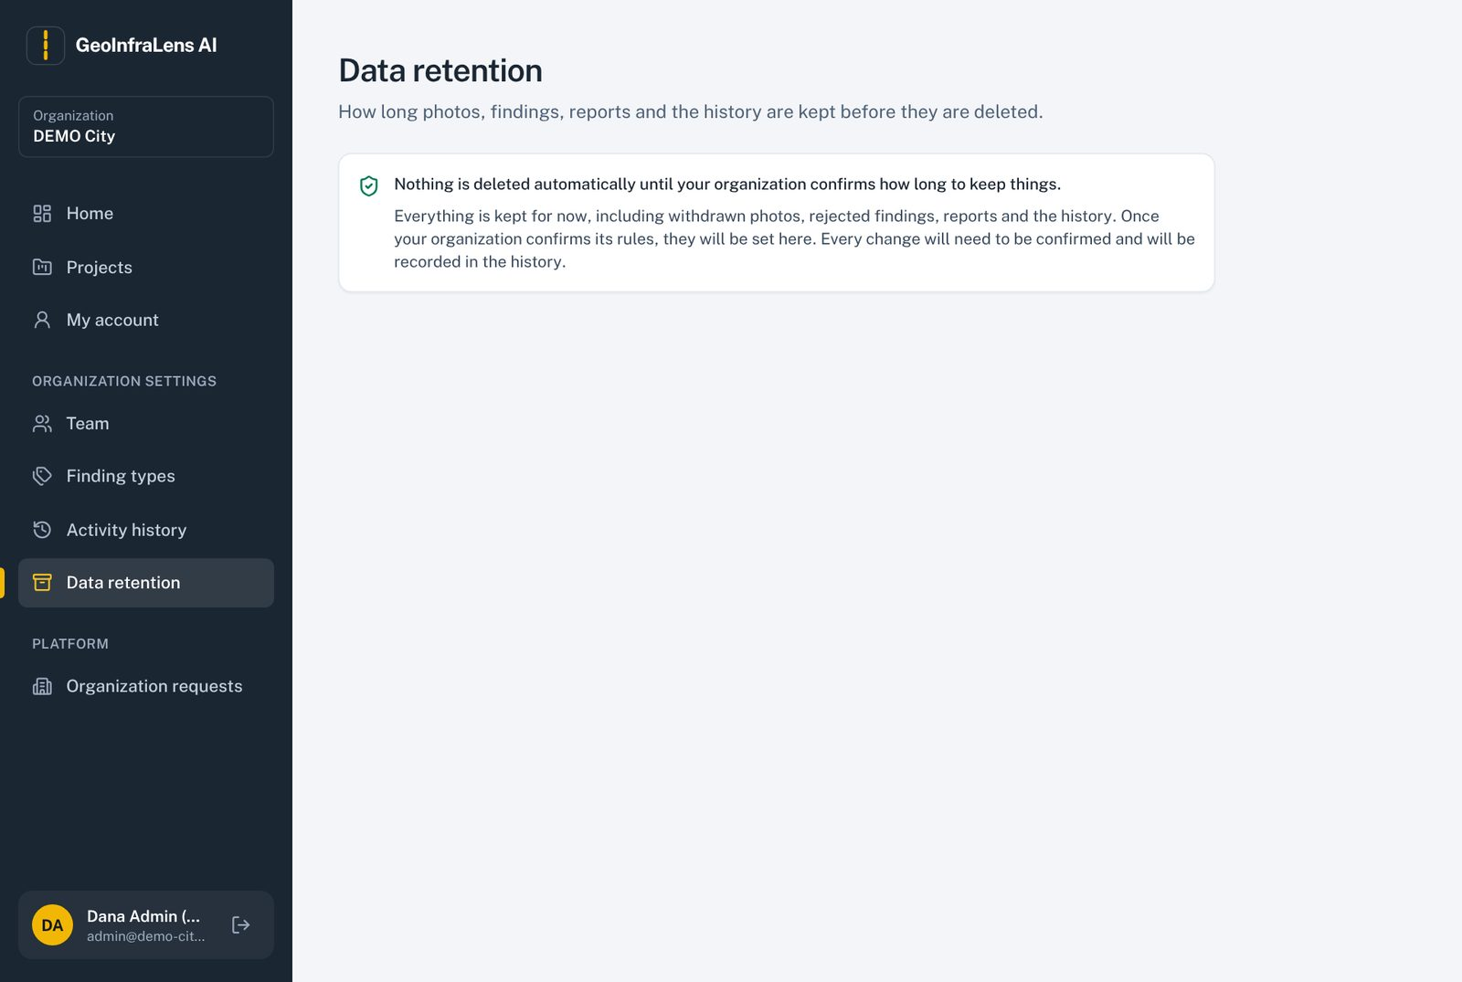
Figure 29. Data retention page.

5.17 My account
Shows your name, email and the organizations you belong to, and the Sign out button. To change your password, ask your administrator for a reset link.
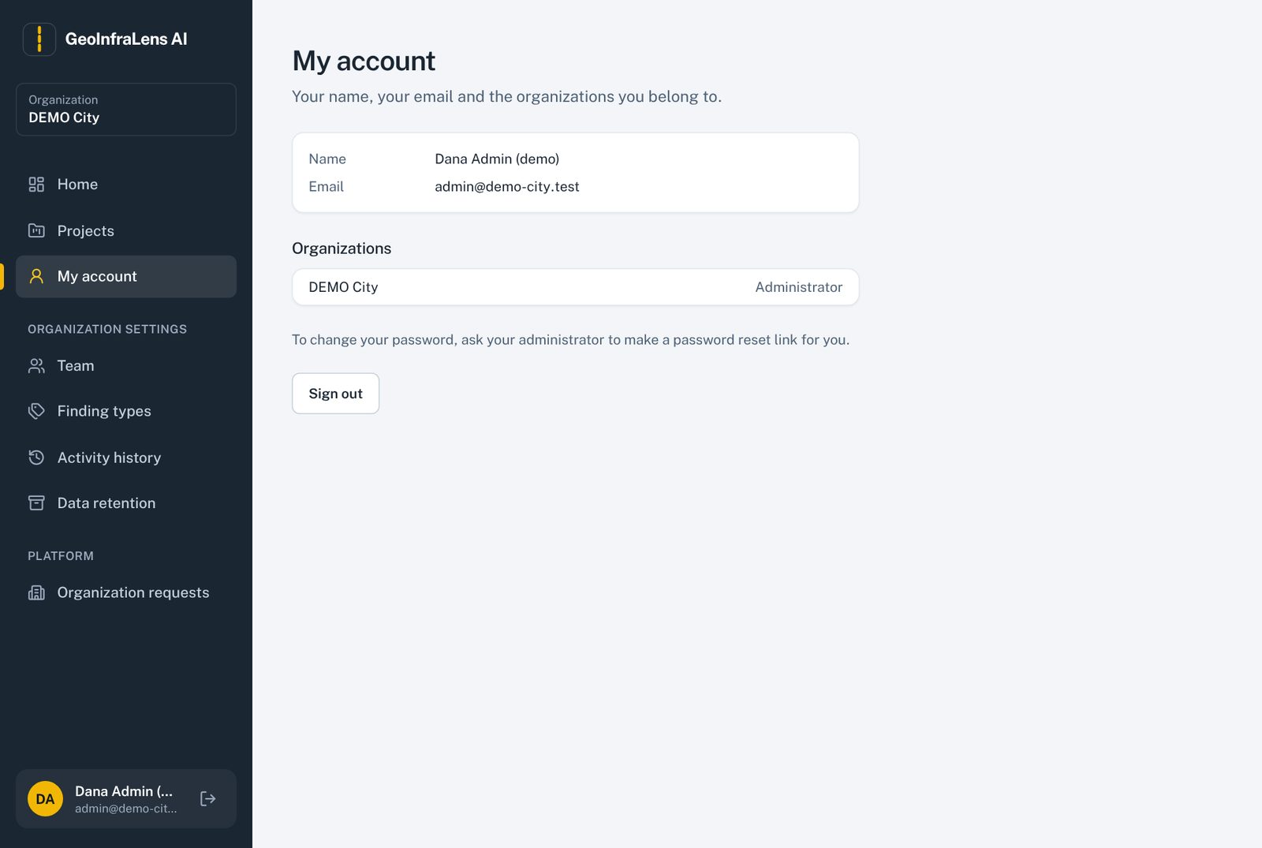
Figure 30. My account.

6. Complete workflow from start to finish
- Organization joins. The organization sends Request access; a platform admin approves and emails the invitation link; the contact sets a password and becomes organization admin.
- Team is invited. The organization admin invites managers, reviewers, collectors and viewers from Team.
- Project is created. A manager creates a project, sets the survey area (search, draw or file), finding types and reviewers, and adds the team.
- Photos are collected. Field collectors take road photos and upload them; locations are read from GPS or picked on the map.
- AI check runs. A manager or collector sends new photos to the AI; it suggests possible problems with boxes on the photos.
- Reviewer decides. The technical reviewer verifies, rejects or marks each suggestion for a field check, sets type, severity and location.
- Priority is calculated. Verified findings get a transparent priority score from the configured inputs.
- Inspections are done. The manager plans inspections; the assigned person records the outcome with evidence.
- Reports are shared. The manager creates CSV, GeoJSON or PDF reports and shares approved ones with viewers.
- Everything is recorded. Every step appears in the project and organization history.

7. Technology stack and why we chose it
Constraints: one developer, free and open-source software, the simplest option that is still secure and suitable for production.

7.1 Frontend (screens)
Technology | Why
React 19 + Vite + TypeScript | Component-based responsive app; fast development builds; type checking catches errors early.
Tailwind CSS 4 | Consistent, accessible styling with the project's asphalt and road-marking-yellow theme.
React Router | Page navigation and addresses that can be shared (including filters).
TanStack Query | Server calls with caching, loading and error states, and automatic refresh of AI status.
React Hook Form + Zod | Forms with clear, field-by-field validation messages.
MapLibre GL + Terra Draw | Interactive maps, finding pins, and drawing or adjusting the survey area.
OpenFreeMap tiles; Nominatim search | Free base map and free place search based on OpenStreetMap (terms to be checked before the pilot).
Recharts | Dashboard charts, loaded only on pages that show charts.

7.2 Backend (server)
Technology | Why
Python 3.13 + FastAPI | Fast, typed web API in the same language as the AI code.
Pydantic | Validates every request and shapes every response.
SQLAlchemy 2 (sync) + GeoAlchemy2 | Database models shared by the API and background workers, with map (PostGIS) columns.
Alembic | Versioned, reviewable database changes (migrations), applied automatically when the API starts.
Session-cookie sign-in, Argon2 passwords | Sessions live in the database, so removing a user ends their access immediately (unlike JWT tokens).
Central permission check (custom RBAC) | One place in code decides who may do what; every protected request uses it.
Celery + Valkey (Redis-compatible) | Background jobs: AI checks and report building, with retries. Job status is stored in PostgreSQL.
Pillow + OpenCV | Reading GPS and time from photos, previews, blur and darkness checks.
WeasyPrint | PDF reports from HTML templates.

7.3 Data
Technology | Why
PostgreSQL 17 + PostGIS 3.5 | All records and map shapes: boundaries, photo points, distance and inside-area checks.
Private file storage | Original photos, previews and reports in a private Docker volume, sent only through the API after a permission check. Can move to S3-type storage by changing one file.

7.4 AI and machine learning
Technology | Why
PyTorch + torchvision Faster R-CNN (ResNet-50 FPN) | Proven object detector with a permissive (BSD) licence; no paid or proprietary API.
RDD2022 public dataset | Public road-damage photos (CC BY-SA 4.0) for the first model; US images excluded because of Google terms.
Google Colab (Pro) | GPU time for training.
CVAT / Label Studio (planned) | Free tools to mark local road photos for the next model version.

7.5 Tooling
- Docker Compose: database, queue, API and worker in one command.
- Backend checks: pytest, Ruff (style), mypy (strict types).
- Frontend checks: Vitest + Testing Library, oxlint, TypeScript.
- Git and GitHub for version control; Vercel for the frontend.

7.6 Options we decided against
Option | Reason
JWT sign-in tokens | A token stays valid after a user is removed; revoking needs extra machinery.
Ultralytics YOLO | AGPL-3.0 licence could force open-sourcing the platform or buying a licence.
Public OpenStreetMap tile servers | Their usage policy forbids heavy app use.
Async SQLAlchemy | Extra complexity with no benefit at pilot scale; the workers are synchronous anyway.

8. System architecture
The system has six parts. The browser talks only to the website address; every data request goes to the API under /api, which checks permissions before touching the database or files.
Part | What it does | Where it runs now
Frontend (React) | All screens. | Vercel
API (FastAPI) | Sign-in, permissions, projects, photos, findings, reviews, reports. | Docker on the developer laptop, through a Cloudflare tunnel
Worker (Celery) | Runs AI checks and builds reports in the background; holds the AI model in memory. | Docker on the laptop
Queue (Valkey) | Passes jobs from the API to the worker. | Docker on the laptop
Database (PostgreSQL + PostGIS) | All records and map shapes. | Docker on the laptop (volume db-data)
File storage | Original photos, previews, reports, evidence. | Docker on the laptop (volume storage-data)

8.1 How a request travels
Browser → Vercel (screens) → /api is forwarded by vercel.json → Cloudflare tunnel → API on port 8000 → database / files. The database and queue ports are open only inside the laptop and never exposed to the internet.

8.2 How an AI check works
- A user clicks Check photos now; the API creates one analysis job per photo (safe to repeat; duplicates are not created).
- The job is queued; the worker opens the photo the right way up and runs the model.
- Results are checked against the AI output contract and saved as candidate findings with model version, box and certainty.
- The screens refresh automatically and show the suggestions, labelled as trial results.

8.3 Code layout
Folder | Contents
frontend/src | pages, components, api (server calls), lib (helpers), tests next to each file
backend/app/api | web addresses (routes)
backend/app/services | business rules (projects, images, analysis, reviews, priority, reports, organization requests)
backend/app/models | database tables
backend/app/core | settings, security, central permission check
backend/app/ai | test detector and trial model loader
backend/alembic | database migrations (0001–0008)
ml/ | dataset preparation, training, evaluation, notebooks, reports
documentation/ | requirements, design, decisions, progress log

9. The AI model
Model version | frcnn-rdd2022-0.1 (Faster R-CNN ResNet-50 FPN)
Classes | pothole, surface cracking, pavement deterioration
Training data | RDD2022 public road photos: 25,513 training and 2,837 validation photos (US images and China drone images left out; Czech photos kept aside as the test set)
Training | 12 rounds (epochs) on Google Colab; best round 10, validation mAP50 0.580
Final test | Run once on 2,829 locked photos from the Czech Republic (a country the model never saw): NOT PASSED
Status | Running as a TRIAL (change request CR-003): every result is labelled "TRIAL MODEL: accuracy not approved" and reviewed by a person
Speed / memory | About 3–3.5 seconds per photo on a normal computer (no GPU); about 1.5 GB memory

Class | Found (recall) | Correct when it flags (precision) | Real damage boxes in test
Pothole | 8% | 27% | 197
Surface cracking | 17% | 47% | 1,387
Pavement deterioration | 34% | 22% | 161
Final test results on unseen Czech roads. Pass marks are still placeholders until the partner agrees them (PI-17).

9.1 Safeguards
- Off unless switched on with one setting (ANALYSIS_MODEL_VERSION); switching back is the same setting.
- Only the exact tested file is accepted (SHA-256 fingerprint check).
- Cut-offs were chosen on validation photos, never on the test set.
- An empty result is shown as "found nothing, check the photo yourself", never as "no damage".

9.2 Plan to improve it
- Get the client's written permission to use their photos for training (PI-04).
- Collect 200–300 local road photos; keep about 50 aside as a new test set.
- Mark damage boxes (CVAT or Label Studio, with AI pre-marking checked by a person).
- Fine-tune the current model on Colab Pro, then run a fair test once with pass marks agreed in advance.

10. Data model
21 tables in PostgreSQL. Rules: the database stores facts (who holds which role, what happened); what each role may do lives in code. Nothing is hard-deleted; history tables are add-only.
Area | Tables
People and access | users, sessions, organizations, organization_memberships, invitations, password_resets, organization_requests
Projects | projects, project_members, finding_types, severity_rubrics
Photos and AI | images, analysis_jobs, findings, finding_images
Review | review_events
Priority and inspections | priority_configs, priority_scores, inspections
Reports | reports
History | audit_events

- Original AI predictions are protected by a database trigger; corrections are stored next to them.
- Original GPS and corrected locations are separate columns.
- Settings that may change (severity scale, priority weights) are versioned; each record points to the version it used.

11. API overview
All addresses start with /api/v1. Errors always have the same shape: {"error": {"code", "message", "details", "request_id"}}. The interactive API page is at /api/docs in development mode only.
Group | Examples
Sign-in | /auth/login, /auth/logout, /auth/me, /auth/invitations/{token}, /auth/password-resets/{token}
Organizations | /organizations/{org_id} (members, invitations, finding types, history, dashboard)
Projects | /organizations/{org_id}/projects, /projects/{project_id} (team, history)
Photos | /projects/{project_id}/images, /images/{image_id} (file, preview, location, withdraw)
AI analysis | /projects/{project_id}/analysis-jobs, /analysis-jobs/{job_id} (retry)
Findings and review | /projects/{project_id}/findings (and findings.geojson), /findings/{finding_id} (review, history)
Priority and inspections | /projects/{project_id}/priority-list, /projects/{project_id}/priority-configs, /findings/{finding_id}/inspections, /inspections/{inspection_id}
Reports | /projects/{project_id}/reports, /reports/{report_id}
Organization requests | POST /organization-requests (public); /platform/organization-requests (platform admins)
Health | /api/health, /api/health/ready

12. Security and privacy
- Every protected request is checked on the server. No access to a project gives "not found" (its existence is not revealed); access without the right gives "permission denied".
- Sign-in cookie is httpOnly, Secure and SameSite=Lax; requests that change data from other websites are refused (Origin check).
- Passwords are stored as Argon2 hashes; sign-in locks for 15 minutes after 5 wrong attempts.
- Removing a member or deactivating a user ends their sessions immediately.
- Invitation and reset links are single-use, expire, and only their scrambled form is stored.
- Photos and reports are never served directly; they are sent through the API after a permission check.
- Platform admin can only be given by a server command, never from the website.
- Secrets live in .env, which is never committed to Git.
- Client photos must not go to outside services (including training on Colab) until the client approves in writing (PI-04).

13. Configuration settings
Settings are read from the .env file in the project folder. Never share or commit .env; .env.example shows the names with safe sample values.
Setting | Meaning
APP_ENV | development or production (production hides the API documentation page).
POSTGRES_USER / POSTGRES_PASSWORD / POSTGRES_DB | Database account used by the db container.
DATABASE_URL | How the API reaches the database (same user and password).
REDIS_URL | Address of the job queue.
STORAGE_DIR | Private folder for photos and reports inside the containers.
ANALYSIS_MODEL_VERSION | stand-in-0.1 (test detector) or frcnn-rdd2022-0.1 (trial model).
PUBLIC_APP_URL | The website address people use; used in invitation links and the Origin check. Must exactly match, e.g. https://geo-ai-liart.vercel.app (no slash at the end).
SESSION_COOKIE_SECURE | Keep true.
VITE_MAP_STYLE_URL (frontend) | Optional: a different base map style.
VITE_GEOCODER_URL (frontend) | Optional: a different place-search service.

14. Deployment

14.1 Current setup (demo)
Part | Where
Code | GitHub (private repository), branch development
Screens | Vercel, project geo-ai, Production branch: development; vercel.json forwards /api to the backend
Backend, worker, database, queue, photos, model | Docker Desktop on the developer laptop
Public address for the backend | Cloudflare quick tunnel (address changes every restart)

14.2 Starting the live demo after a restart
- Start Docker Desktop and wait for "Engine running".
- In the project folder run docker compose up -d.
- Run cloudflared tunnel --url http://localhost:8000 and copy the trycloudflare.com address. Keep the window open.
- Put that address into frontend/vercel.json, then git add ., git commit -m "Update tunnel", git push.
- Wait until Vercel → Deployments shows Ready (Production), then open the website.
Common problems
Error 429 when starting the tunnel: Cloudflare limits new quick tunnels; wait 10–15 minutes and try once.
Vercel deployment "Blocked": the Git email must match the GitHub account (git config user.email).
"This request came from another website": PUBLIC_APP_URL must exactly equal the website address; then run docker compose up -d --force-recreate api worker.

14.3 Next steps for an always-on site
Option | Cost | Notes
Named Cloudflare tunnel + own domain | About $10 per year (domain) | Fixed backend address; laptop must still be on.
Oracle Cloud Always Free server | Free | Runs everything 24/7 with Docker; free DuckDNS address with HTTPS by Caddy. Step-by-step guide prepared separately.
Client's cloud (Azure, AWS or Google Cloud) | Roughly $100–300 per month at pilot size (estimate) | Recommended for the real pilot: managed PostgreSQL with PostGIS, S3/Blob storage for photos, client controls the data (PI-18).

15. Operations and maintenance
Run these in PowerShell in the project folder (C:\Users\Developer2025\Desktop\GeoInfraLens AI).
Task | Command
Start the backend | docker compose up -d
Rebuild after code changes | docker compose up -d --build
Stop (data kept) | docker compose stop
Restart API and worker | docker compose restart api worker
See what the API is doing | docker compose logs api --tail 50
Start the frontend locally | cd frontend  then  npm run dev
Create an organization and first admin | docker compose exec api python -m app.cli create-organization --name "…" --admin-email … --admin-name "…"
Make an account platform admin | docker compose exec api python -m app.cli make-platform-admin --email …
Remove platform admin | … make-platform-admin --email … --remove
Load DEMO City data (once) | docker compose exec api python -m app.demo_data
Run backend tests | docker compose exec api pytest

Never run docker compose down -v
The -v option deletes the database and all photos. Use docker compose stop or docker compose down (without -v).

15.1 Backups
- Today: zip backups of the project folder in _backups/ on the laptop.
- Needed before real data: a daily database backup (pg_dump) and a weekly photo backup, copied off the machine, plus a restore that has actually been tested (phase P10).

16. Testing and quality
Area | Result (October 28, 2026)
Backend automated tests | 233 passed (pytest), Ruff and mypy strict clean
Frontend automated tests | 90 passed (Vitest), TypeScript, oxlint and production build clean
ML tests | 70 passed (data split, training safety, evaluation)
Browser walk-throughs | Every screen checked as admin, reviewer, collector and viewer on desktop and phone
Independent code checks | Review logic (4 issues) and priority/reports (8 issues): all fixed
Owner acceptance | P0–P4 signed off; P5–P7 waiting for owner test (testing guide: 06-demo/testing-guide-p5-p7.md)

17. Known limitations and open items
Item | Status / next step
AI accuracy | Trial only; improve with local photos after client permission (section 9.2).
Partner decisions | All 19 partner inputs are placeholders. Blocked: training permission (PI-04), qualified reviewer (PI-07), AI pass marks (PI-17).
Live availability | Depends on the laptop and a temporary tunnel address; move to a server (section 14.3).
Emails | The app does not send emails yet; invitation and reset links are copied and sent by hand.
Map and place search | Free OpenFreeMap and Nominatim services; check terms and limits before the pilot.
Severity scale and priority weights | Sample values until the client confirms them.
Face and number-plate masking | Not built; photos are not shared outside the organization until a policy exists (PI-14).
System testing (P9) | Not started: full acceptance checklist, security, performance and usability tests.
Backups and monitoring | Planned for pilot deployment (P10).

18. Troubleshooting
What you see | Likely cause | What to do
"Could not load your account" / page not found on the live site | Backend or tunnel not running, or vercel.json has an old address | Start Docker and the tunnel; update vercel.json and push.
"This request came from another website and was refused" | Opened a long deployment address, or PUBLIC_APP_URL does not match | Use the main address; fix .env and recreate api and worker.
"Too many attempts" | 5 wrong passwords in 15 minutes | Wait 15 minutes.
AI check failed: model file missing / not the tested model | Model file missing or different | Put frcnn-rdd2022-0.1.pt in ml/models and restart.
No "Organization requests" in the menu | Account is not platform admin, or old session | Run make-platform-admin, then sign out and in.
Address search cannot be reached | No internet, or the free search is busy | Try again later or draw the area by hand.
Docker "pipe" error | Docker Desktop not running | Start Docker Desktop.

19. Glossary
Term | Meaning
Finding | A possible road or sidewalk problem, suggested by the AI or added by a person.
Candidate / AI suggestion | A finding from the AI that no reviewer has checked yet.
Verified finding | A finding a technical reviewer confirmed.
AI certainty (confidence) | How sure the AI is that something is there. Not severity.
Severity | How serious the problem is, chosen by the reviewer on the organization's scale.
Survey area | The area on the map that a project covers.
GeoJSON | A standard file format for map shapes.
PostGIS | The map extension of the PostgreSQL database.
Migration | A recorded, versioned change to the database structure.
Tunnel | A secure connection that gives a program on a laptop a public web address.
mAP50 / recall / precision | Standard measures of how well a detector finds problems (recall) and how often its flags are right (precision).
Trial model | The trained AI used for testing in the app while its accuracy is not approved.

